**JAVA SWING BASED –Car-D Portal Database For Students- SQL CONNECTIVITY USING JDBC**

*A*

*Report*

*Submitted in partial fulfilment of the*

*Requirements for the award of the Degree of*

**BACHELOR OF ENGINEERING**

**IN**

**INFORMATION TECHNOLOGY**

**By**

**T. Pragna<1602-21-737-192>**

**Under the guidance of Ms B. Leelavathy**



**Department of Information Technology**

**Vasavi College of Engineering (Autonomous)**

**(Affiliated to Osmania University)**

**Ibrahimbagh, Hyderabad-31**

**2022-2023**

**BONAFIDE CERTIFICATE**

This is to certify that this project report titled

‘**Car-D Portal*’***

is a project work of ***T. Pragna***

bearing roll no. 1602-21-737-192

who carried out

this project under my supervision

in the IV semester

of the academic year 2022- 2023

Signature Signature

External Examiner Internal Examiner

**ABSTRACT**

CAR-D (Cargo - Data) is a web-based portal for collection & compilation, analysis and dissemination of all the cargo and cruise movement data for IWAI and its stakeholders. Portal gives access of the data to general public showcasing IWAI capabilities and potential of inland waterways transport. The Car-D portal helps in collating real-time information on all the cargo and cruise traffic data of the National Waterway. It also provides information related to the infrastructure of Waterways. It provides access to all stakeholders and general public thus bringing trust in the data being reported for IWT sector. It assists potential shippers & cargo owners in identifying cargo type and commodity at various waterways, terminals and jetties

**REQUIREMENTS:**

Overall 7 tables are required for the ER model representation , they are:

1. Cruise_ship
2. Cargo_ship
3. movement
4. reserves
5. passengers

**Table 1:** Cruise_ship

**Attributes:**

cruise_id varchar(8) primary key

cruise_name varchar(15)

no_of_passengers integer

rating integer

fare integer

**Domain Types:**

- : no_of_passengers rating , fare :integer

-: cruise_id , cruise_name :varchar

**Constraints:**

- Primary key: cruise_id

**Table 2: Cargo_ship**

**Attributes:**

cargo_id varchar(8) primary key

cargo_name varchar(15)

capacity integer

load varchar(10)

**Domain Types:**

- capacity: integer

- cargo_name,cargo_id,load: varchar

**Constraints:**

- Primary key: cargo_id

**Table 3: Movement**

**Attributes:**

starting_port varchar(10)

destination_port varchar(10)

ship_id varchar(8) primary key

starting_date date

**Domain Types:**

- starting_port, destination_port, ship_id: varchar

- starting_date : date

**Constraints:**

- Foregin key : Ship_id references cruise_ship

**Table 4: Reserves**

**Attributes:**

ship_id varchar(8) primary key

booking_id varchar(8)

date_of_reservation date

starting_port varchar(10)

destination_port varchar(10)

**Domain Types:**

- starting_port ,destination_port, ship_id ,booking_id :varchar

- date_of_reservation: date

**Constraints:**

- Primary key: booking_id

- Foreign keys: ship_id

**Table 5: Passengers**

**Attributes:**

booking_id varchar(5) primary key

name varchar(15)

**Domain Types:**

- booking_id, name: varchar

**Constraints:**

- Primary key: booking_id

**MAPPING CARDINALITIES:**

-One passenger can reserve any number of cruise ships

-One ship has only on movement on a particular day

**DESIGN ( ENTITY RELATIONSHIP MODEL ):**

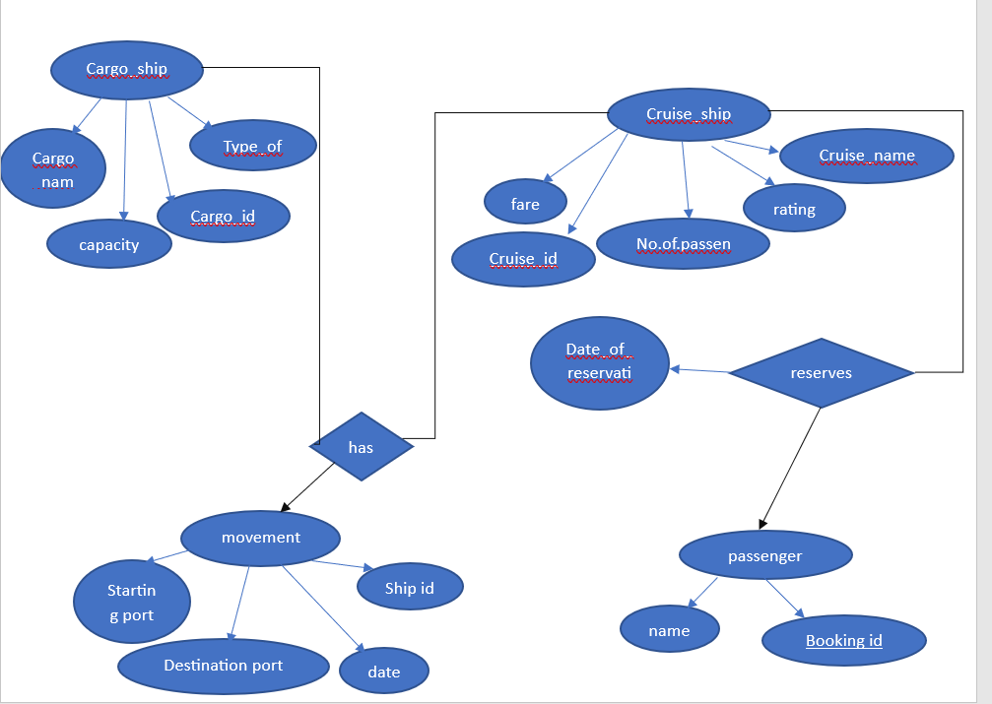

**DDL COMMANDS:**

**Table 1 :Cruise_ship:**

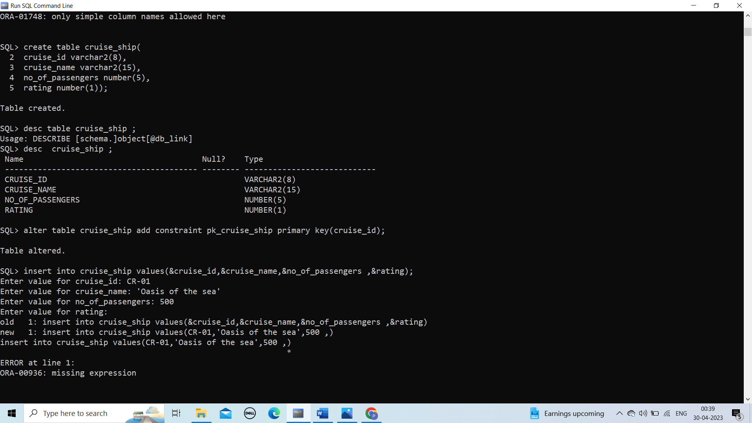

**Table 2: Cargo_ship:**

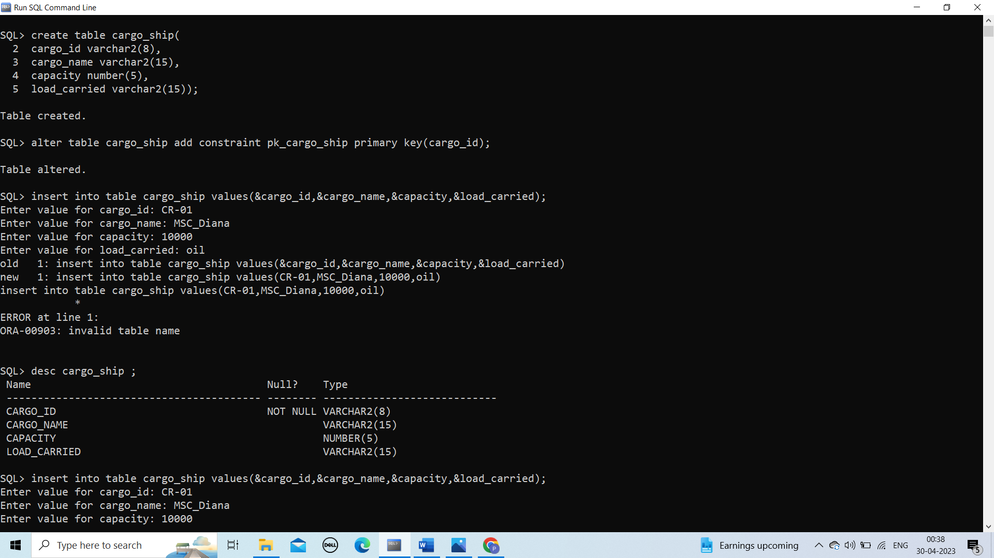

**Table 3:Movemnet:**

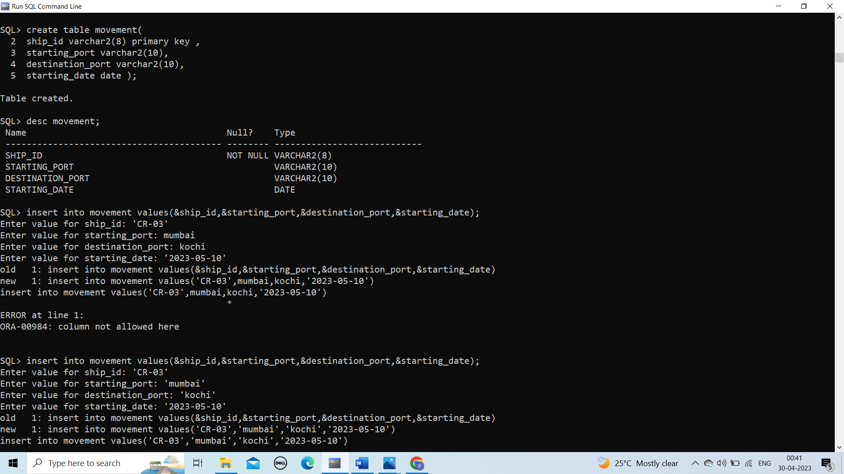

**Table 4: Reserves:**

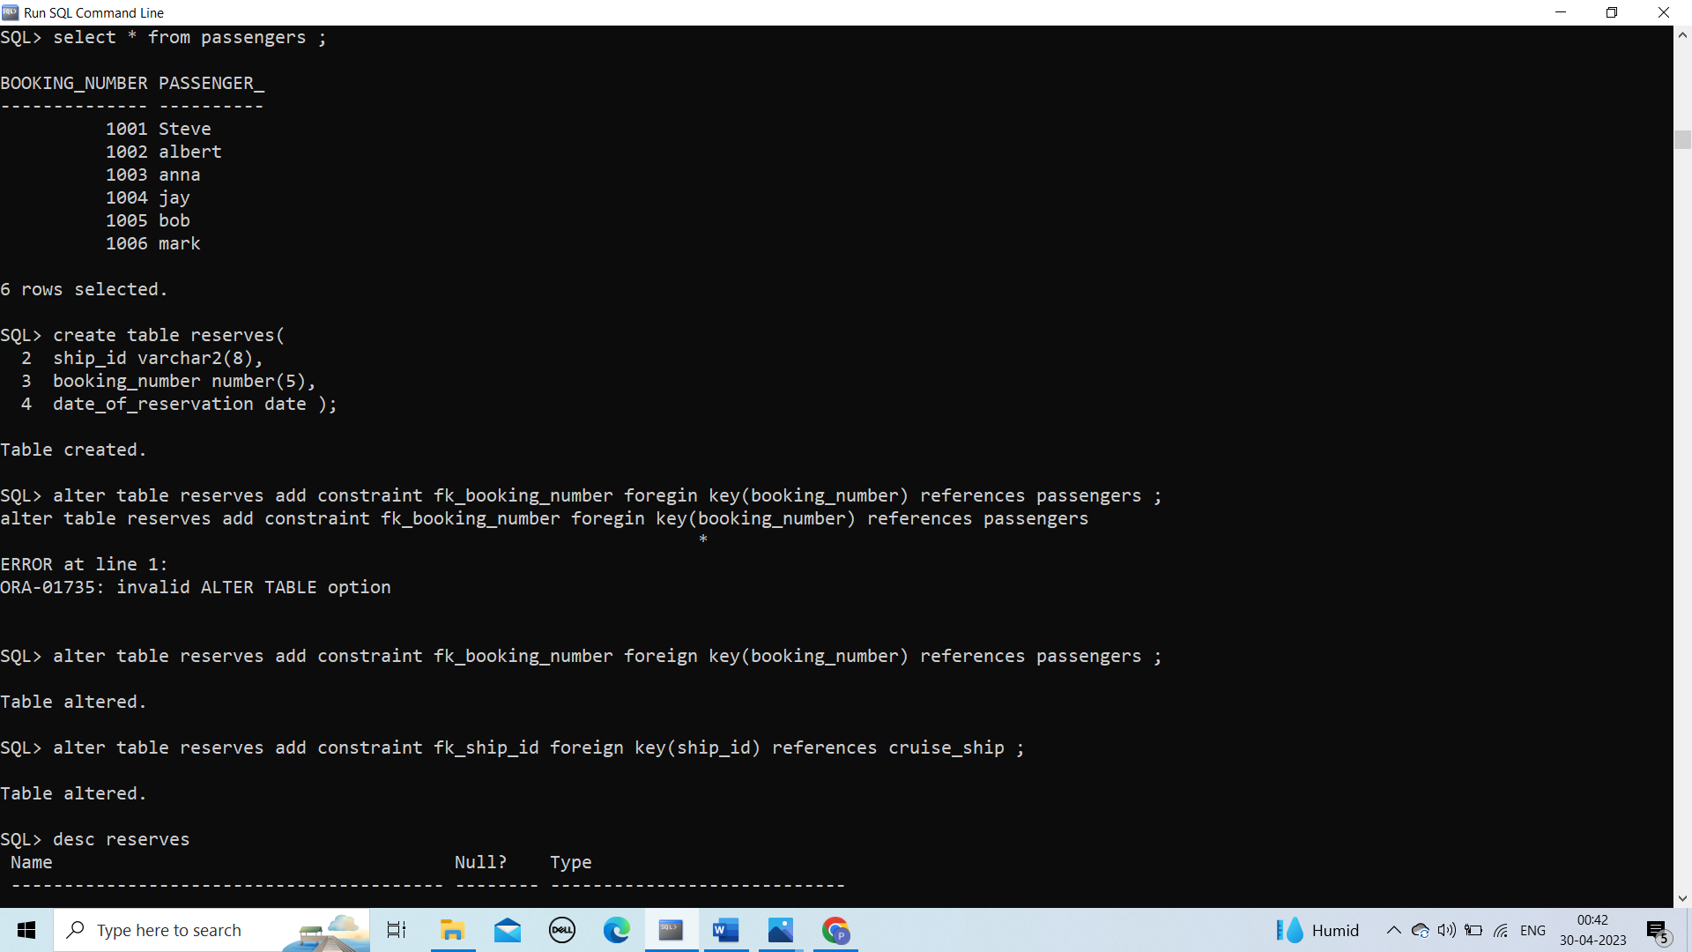

**Table 5: Passengers:**



**DML OPERATIONS:**

TABLE 1 : Cargo_ship



TABLE 2: Cruise_ship

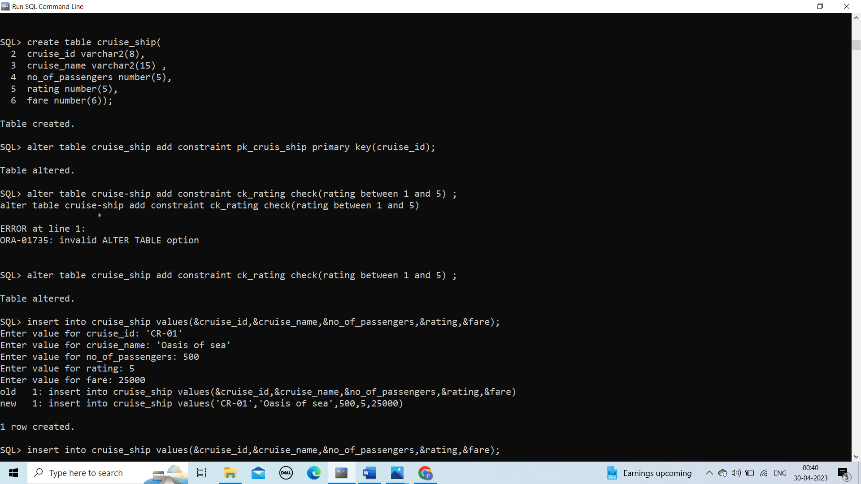

TABLE 3: Movement



TABLE 4 : Reserves

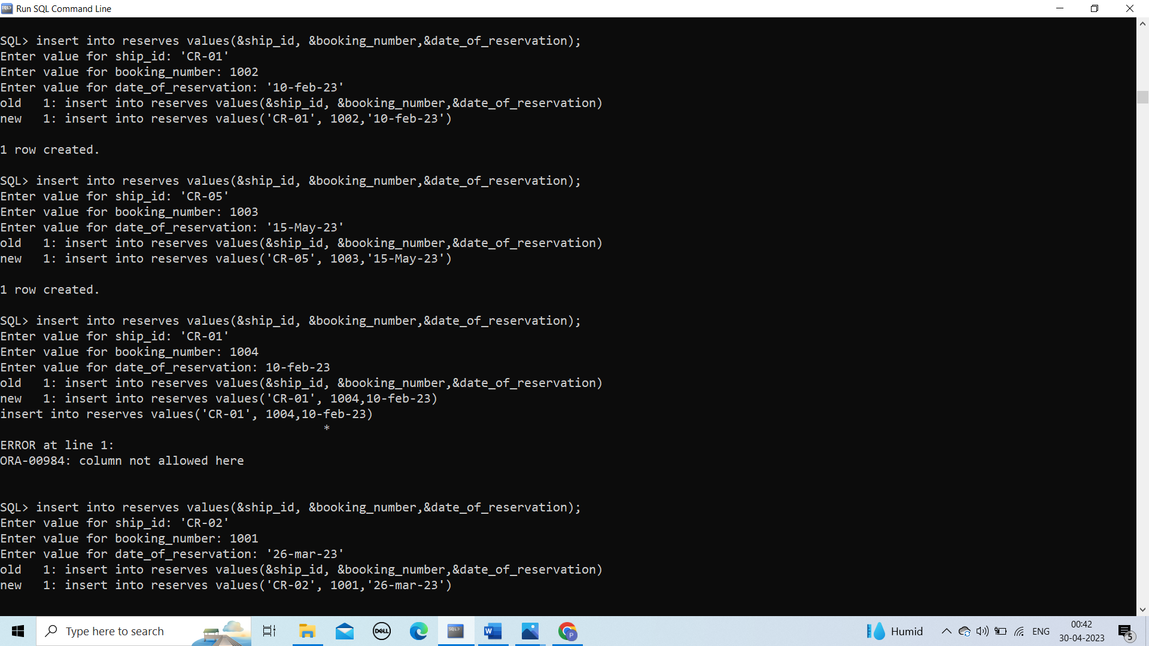

TABLE 5 : Passengers

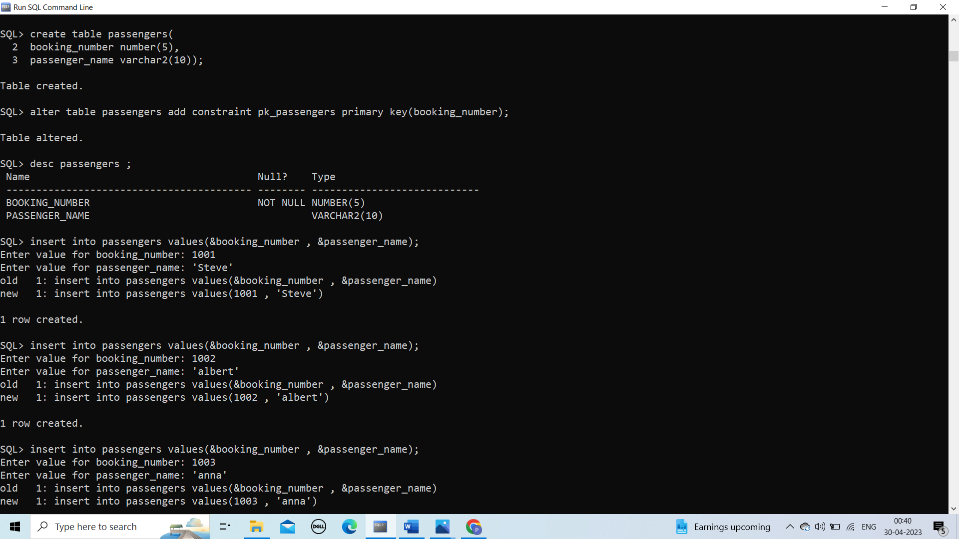

**IMPLEMENTATION**

**JAVA-SQL Connectivity using JDBC:**

**Java Database Connectivity (JDBC)** is an application programming interface (API) for the programming language Java, which defines how a client may access a database. It is a Java-based data access technology used for Java database connectivity. It is part of the Java Standard Edition platform, from Oracle Corporation. It provides methods to query and update data in a database and is oriented towards relational databases.

The connection to the database can be performed using Java programming (JDBC API) as:

private void connectToDatabase() {

        try {

            String url = "jdbc:mysql://localhost:3306/dbms";

            String username = "root";

            String password = "pragna";

            connection = DriverManager.getConnection(url, username, password);

            statement = connection.createStatement();

        } catch (SQLException e) {

            e.printStackTrace();

        }

    }

**Front End Programs**

**1.HOME PAGE:**

**Source Code**

package pragna;

import javax.swing.*;

import java.awt.*;

import java.awt.event.*;

public class MainPage extends JFrame {

/**

*

*/

private static final long serialVersionUID = 1L;

private JButton retrievedetailsButton;

public MainPage() {

// Set frame properties

setTitle("Improvement of Car-D portal");

setDefaultCloseOperation(JFrame.EXIT_ON_CLOSE);

// Create label

JLabel welcomeLabel = new JLabel(" Improvement of Car-D portal ");

welcomeLabel.setFont(new Font("Arial", Font.BOLD, 18));

welcomeLabel.setHorizontalAlignment(SwingConstants.CENTER);

welcomeLabel.setBorder(BorderFactory.createEmptyBorder(20, 0, 20, 0));

add(welcomeLabel, BorderLayout.NORTH);

// Create panel for the button

JPanel buttonPanel = new JPanel();

retrievedetailsButton = new JButton("Retrieve Marks");

// buttonPanel.add(retrievedetailsButton);

// Create menu bar

JMenuBar menuBar = new JMenuBar();

// Create menus

JMenu cargo_shipMenu = new JMenu("cargo_ship Details");

JMenu cruise_shipMenu = new JMenu("cruise_ship Details");

JMenu passengersMenu = new JMenu("passengers Details");

JMenu reservesMenu = new JMenu("reserves Details");

JMenu movementMenu = new JMenu("movement Details");

// Create menu item for student menu

JMenuItem viewcargo_shipDetails = new JMenuItem("View cargo_ship Details");

viewcargo_shipDetails.addActionListener(new ActionListener() {

public void actionPerformed(ActionEvent e) {

new CargoShipTableGUI();

}

});

// Create menu item for course menu

JMenuItem viewcruise_shipDetails = new JMenuItem("View cruise_ship Details");

viewcruise_shipDetails.addActionListener(new ActionListener() {

public void actionPerformed(ActionEvent e) {

new CruiseShipTableGUI();

}

});

// Create menu item for enrollment menu

JMenuItem viewpassengersDetails = new JMenuItem("View passengers Details");

viewpassengersDetails.addActionListener(new ActionListener() {

public void actionPerformed(ActionEvent e) {

new PassengersTableApp();

}

});

// Create menu item for semester menu

JMenuItem viewreservesDetails = new JMenuItem("View reserves Details");

viewreservesDetails.addActionListener(new ActionListener() {

public void actionPerformed(ActionEvent e) {

new ReservesTableApp();

}

});

// Create menu item for grade menu

JMenuItem viewmovementDetails = new JMenuItem("View movement Details");

viewmovementDetails.addActionListener(new ActionListener() {

public void actionPerformed(ActionEvent e) {

new MovementTableGUI();

}

});

// Add menu items to respective menus

cargo_shipMenu.add(viewcargo_shipDetails);

cruise_shipMenu.add(viewcruise_shipDetails);

passengersMenu.add(viewpassengersDetails);

reservesMenu.add(viewreservesDetails);

movementMenu.add(viewmovementDetails);

// Add menus to the menu bar

menuBar.add(cargo_shipMenu);

menuBar.add(cruise_shipMenu);

menuBar.add(passengersMenu);

menuBar.add(reservesMenu);

menuBar.add(movementMenu);

// Set the menu bar

setJMenuBar(menuBar);

// Add the button panel to the frame

add(buttonPanel, BorderLayout.CENTER);

// Set button action for "Retrieve Marks"

/* retrievedetailsButton.addActionListener(new ActionListener() {

public void actionPerformed(ActionEvent e) {

RetrieveProgram retrieveProgram=new RetrieveProgram();

retrieveProgram.setVisible(true);

}

});*/

// Add window listener to handle maximizing the window

addWindowStateListener(new WindowStateListener() {

public void windowStateChanged(WindowEvent e) {

if ((e.getNewState() & Frame.MAXIMIZED_BOTH) == Frame.MAXIMIZED_BOTH) {

System.out.println("Window maximized");

} else {

System.out.println("Window not maximized");

}

}

});

// Set frame size and visibility

setSize(800, 600);

setVisible(true);

}

public static void main(String[] args) {

new MainPage();

}

}

OUTPUT:

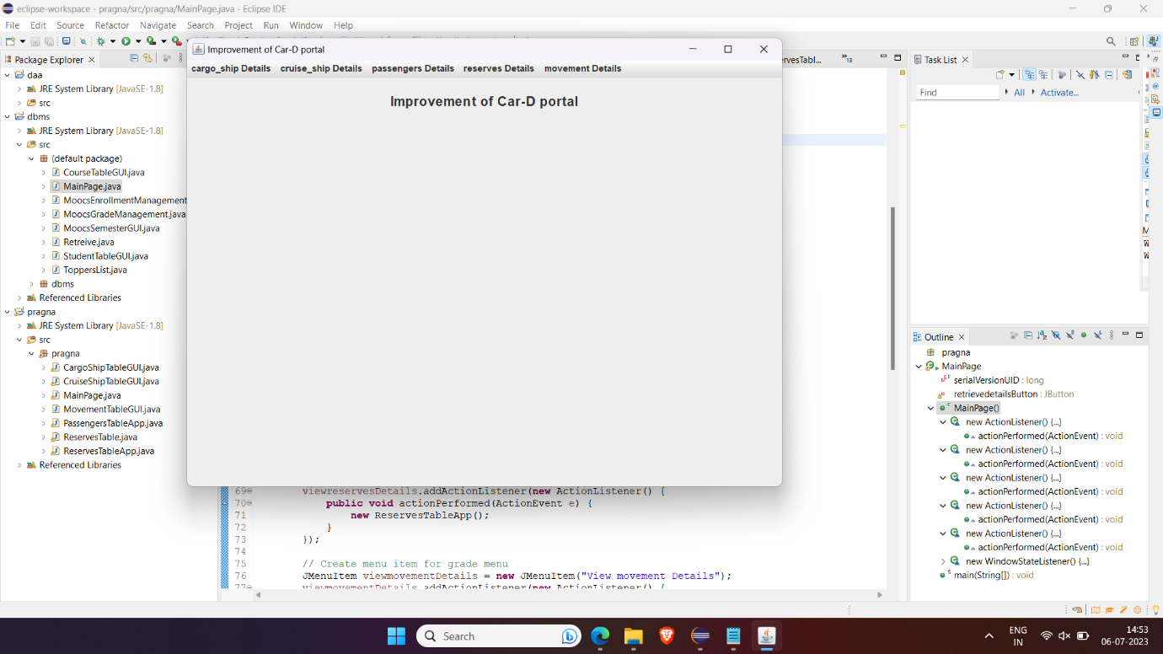

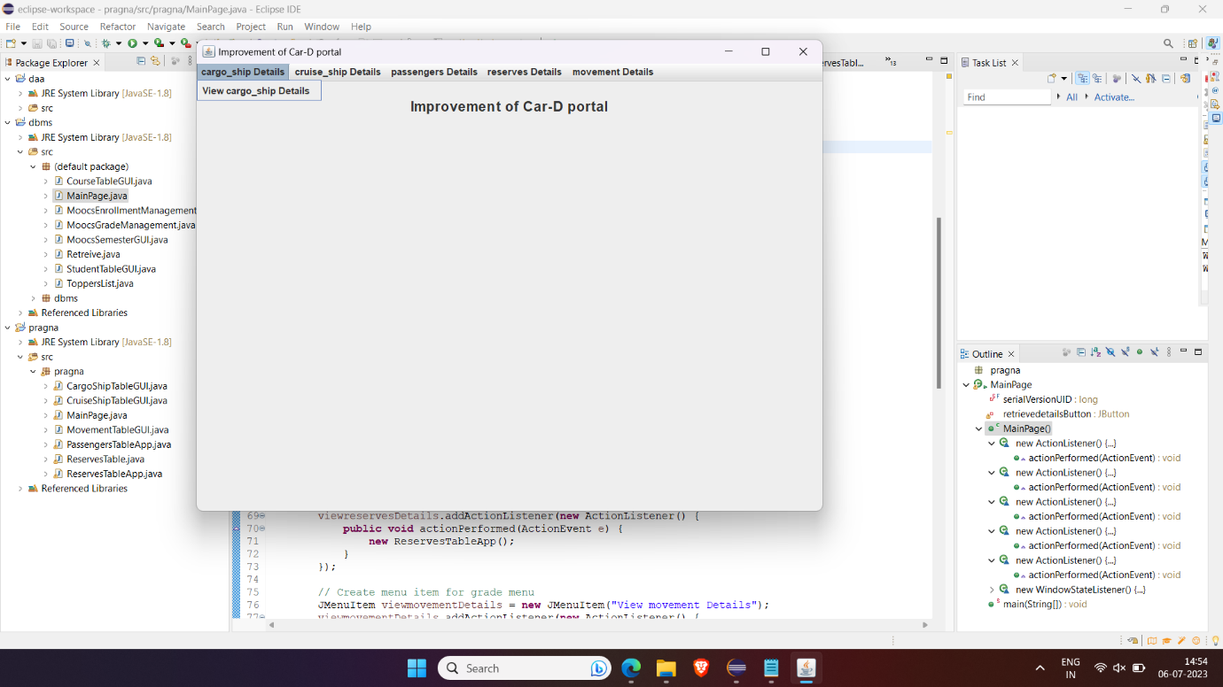

**2.CruiseShipTableApp**

**Source Code:**

//package ShipDetails.Cruise ;

import javax.swing.*;

import javax.swing.table.DefaultTableModel;

import java.awt.*;

import java.awt.event.ActionEvent;

import java.awt.event.ActionListener;

import java.sql.*;

import java.util.Vector;

public class CruiseShipTableApp extends JFrame {

private DefaultTableModel model;

private JTable table;

private JTextField txtCruiseName, txtCruiseId, txtPassengers, txtRating, txtFare;

private Connection connection;

private Statement statement;

public CruiseShipTableApp() {

setDefaultCloseOperation(JFrame.EXIT_ON_CLOSE);

setTitle("Cruise Ship Table");

setSize(600, 400);

setLocationRelativeTo(null);

// Create table model

model = new DefaultTableModel();

model.addColumn("Cruise Name");

model.addColumn("Cruise ID");

model.addColumn("Number of Passengers");

model.addColumn("Rating");

model.addColumn("Fare");

// Create table

table = new JTable(model);

JScrollPane scrollPane = new JScrollPane(table);

add(scrollPane, BorderLayout.CENTER);

// Create panel for input fields

JPanel inputPanel = new JPanel(new GridLayout(5, 2));

// Create input fields

JLabel lblCruiseName = new JLabel("Cruise Name");

txtCruiseName = new JTextField();

JLabel lblCruiseId = new JLabel("Cruise ID");

txtCruiseId = new JTextField();

JLabel lblPassengers = new JLabel("Number of Passengers");

txtPassengers = new JTextField();

JLabel lblRating = new JLabel("Rating");

txtRating = new JTextField();

JLabel lblFare = new JLabel("Fare");

txtFare = new JTextField();

// Add input fields to the panel

inputPanel.add(lblCruiseName);

inputPanel.add(txtCruiseName);

inputPanel.add(lblCruiseId);

inputPanel.add(txtCruiseId);

inputPanel.add(lblPassengers);

inputPanel.add(txtPassengers);

inputPanel.add(lblRating);

inputPanel.add(txtRating);

inputPanel.add(lblFare);

inputPanel.add(txtFare);

// Create panel for buttons

JPanel buttonPanel = new JPanel();

// Create buttons

JButton btnInsert = new JButton("Insert");

JButton btnModify = new JButton("Modify");

JButton btnDelete = new JButton("Delete");

JButton btnDisplay = new JButton("Display");

// Add buttons to the panel

buttonPanel.add(btnInsert);

buttonPanel.add(btnModify);

buttonPanel.add(btnDelete);

buttonPanel.add(btnDisplay);

// Add panels to the frame

add(inputPanel, BorderLayout.NORTH);

add(buttonPanel, BorderLayout.SOUTH);

// Connect to the database

connectToDatabase();

// Insert button action listener

btnInsert.addActionListener(new ActionListener() {

@Override

public void actionPerformed(ActionEvent e) {

insertData();

}

});

// Modify button action listener

btnModify.addActionListener(new ActionListener() {

@Override

public void actionPerformed(ActionEvent e) {

modifyData();

}

});

// Delete button action listener

btnDelete.addActionListener(new ActionListener() {

@Override

public void actionPerformed(ActionEvent e) {

deleteData();

}

});

// Display button action listener

btnDisplay.addActionListener(new ActionListener() {

@Override

public void actionPerformed(ActionEvent e) {

displayData();

}

});

}

// Method to connect to the MySQL database

private void connectToDatabase() {

try {

String url = "jdbc:mysql://localhost:3306/dbms";

String username = "root";

String password = "pragna";

connection = DriverManager.getConnection(url, username, password);

statement = connection.createStatement();

} catch (SQLException e) {

e.printStackTrace();

}

}

// Method to insert data into the table

private void insertData() {

String cruiseName = txtCruiseName.getText();

String cruiseId = txtCruiseId.getText();

String passengers = txtPassengers.getText();

String rating = txtRating.getText();

String fare = txtFare.getText();

if (!cruiseName.isEmpty() && !cruiseId.isEmpty() && !passengers.isEmpty() && !rating.isEmpty() && !fare.isEmpty()) {

try {

String query = "INSERT INTO cruise_ship (Cruise_name, Cruise_id, Number_of_passengers, Rating, Fare) " +

"VALUES ('" + cruiseName + "', '" + cruiseId + "', " + passengers + ", " + rating + ", " + fare + ")";

statement.executeUpdate(query);

Vector<String> row = new Vector<>();

row.add(cruiseName);

row.add(cruiseId);

row.add(passengers);

row.add(rating);

row.add(fare);

model.addRow(row);

clearFields();

} catch (SQLException e) {

e.printStackTrace();

}

} else {

JOptionPane.showMessageDialog(this, "Please fill in all fields.", "Error", JOptionPane.ERROR_MESSAGE);

}

}

// Method to modify data in the table

private void modifyData() {

int selectedRow = table.getSelectedRow();

if (selectedRow != -1) {

String cruiseName = txtCruiseName.getText();

String cruiseId = txtCruiseId.getText();

String passengers = txtPassengers.getText();

String rating = txtRating.getText();

String fare = txtFare.getText();

if (!cruiseName.isEmpty() && !cruiseId.isEmpty() && !passengers.isEmpty() && !rating.isEmpty() && !fare.isEmpty()) {

try {

String query = "UPDATE cruise_ship SET Cruise_name = '" + cruiseName + "', Cruise_id = '" + cruiseId +

"', Number_of_passengers = " + passengers + ", Rating = " + rating + ", Fare = " + fare +

" WHERE Cruise_id = '" + table.getValueAt(selectedRow, 1) + "'";

statement.executeUpdate(query);

table.setValueAt(cruiseName, selectedRow, 0);

table.setValueAt(cruiseId, selectedRow, 1);

table.setValueAt(passengers, selectedRow, 2);

table.setValueAt(rating, selectedRow, 3);

table.setValueAt(fare, selectedRow, 4);

clearFields();

} catch (SQLException e) {

e.printStackTrace();

}

} else {

JOptionPane.showMessageDialog(this, "Please fill in all fields.", "Error", JOptionPane.ERROR_MESSAGE);

}

} else {

JOptionPane.showMessageDialog(this, "Please select a row to modify.", "Error", JOptionPane.ERROR_MESSAGE);

}

}

// Method to delete data from the table

private void deleteData() {

int selectedRow = table.getSelectedRow();

if (selectedRow != -1) {

try {

String cruiseId = (String) table.getValueAt(selectedRow, 1);

String query = "DELETE FROM cruise_ship WHERE Cruise_id = '" + cruiseId + "'";

statement.executeUpdate(query);

model.removeRow(selectedRow);

clearFields();

} catch (SQLException e) {

e.printStackTrace();

}

} else {

JOptionPane.showMessageDialog(this, "Please select a row to delete.", "Error", JOptionPane.ERROR_MESSAGE);

}

}

// Method to display the selected data in the input fields

private void displayData() {

try{

String sql = "select * from cruise_ship";

Statement stmt = connection.createStatement();

ResultSet resultset = statement.executeQuery(sql);

while(resultset.next()){

String cruiseName = resultset.getString("cruise_name");

String cruiseId = resultset.getString("cruise_id");

String number_of_passengers = resultset.getString("number_of_passengers");

String rating = resultset.getString("rating");

String fare = resultset.getString("fare");

Object[] row = {cruiseName,cruiseId,number_of_passengers,rating,fare};

model.addRow(row);

}

resultset.close();

}catch(SQLException e){

e.printStackTrace();

}

}

// Method to clear input fields

private void clearFields() {

txtCruiseName.setText("");

txtCruiseId.setText("");

txtPassengers.setText("");

txtRating.setText("");

txtFare.setText("");

}

public static void main(String[] args) {

SwingUtilities.invokeLater(new Runnable() {

@Override

public void run() {

new CruiseShipTableApp().setVisible(true);

}

});

}

}

OUTPUT:

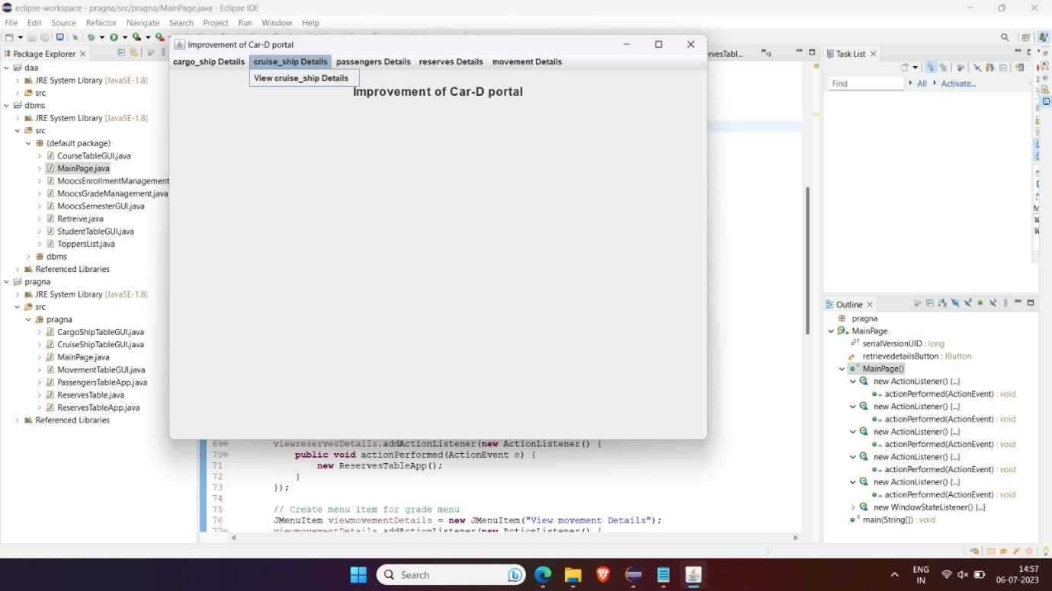

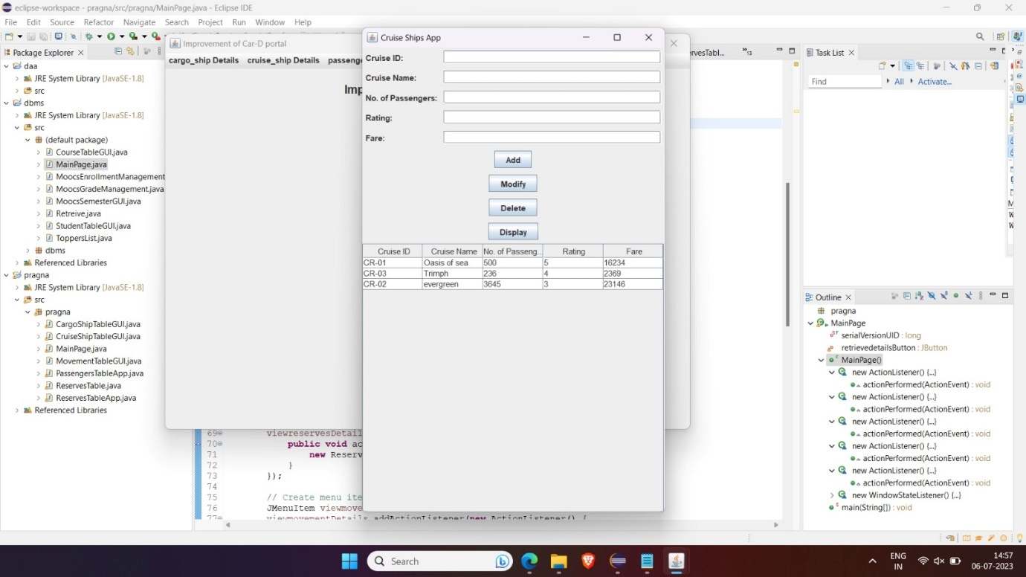

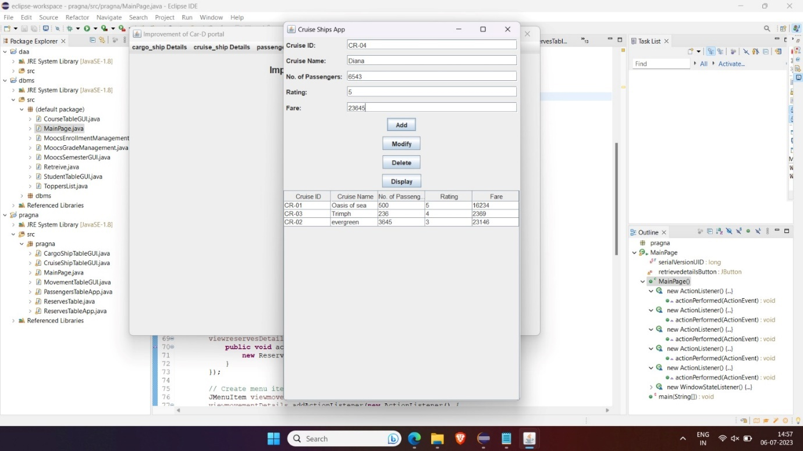

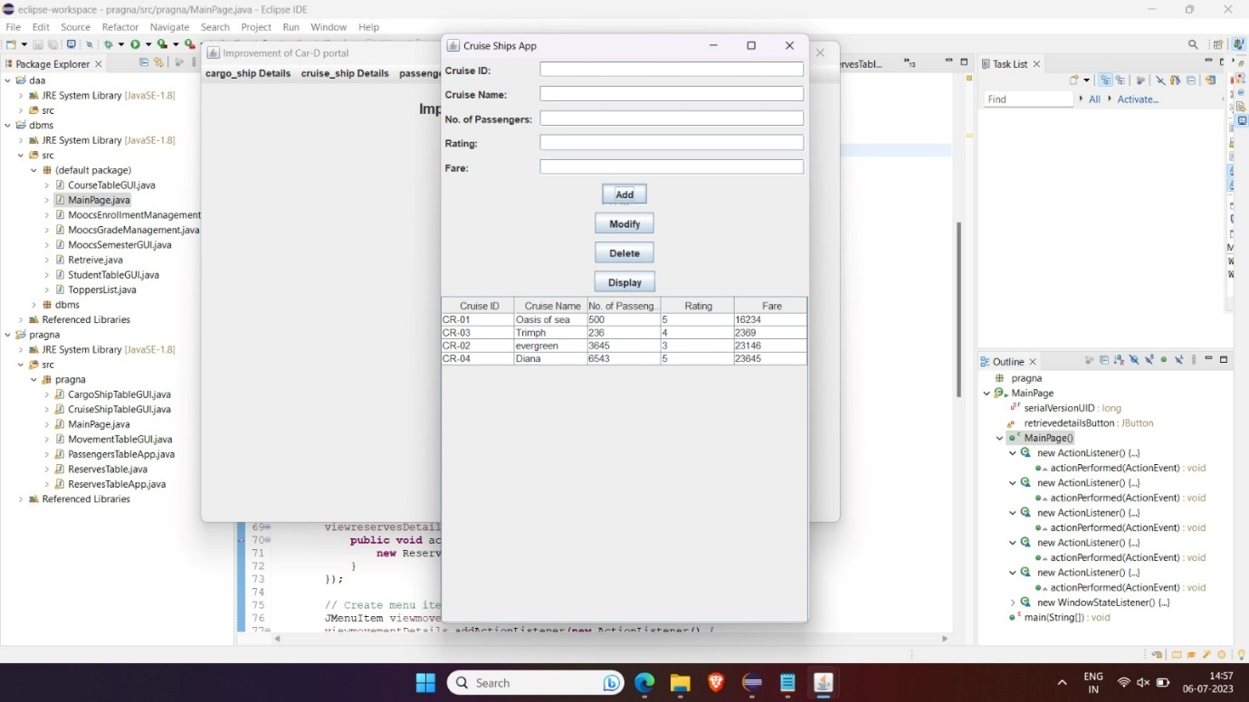

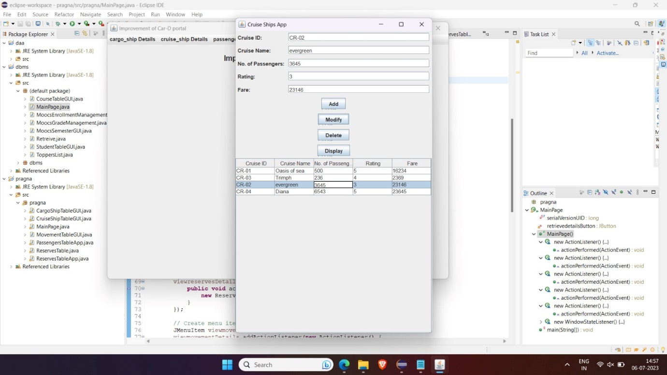

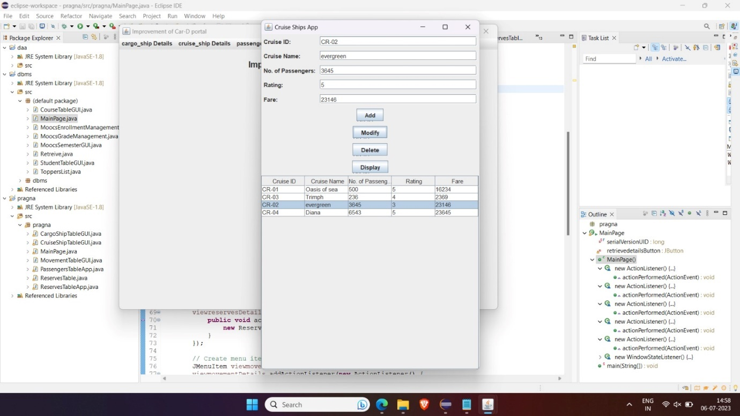

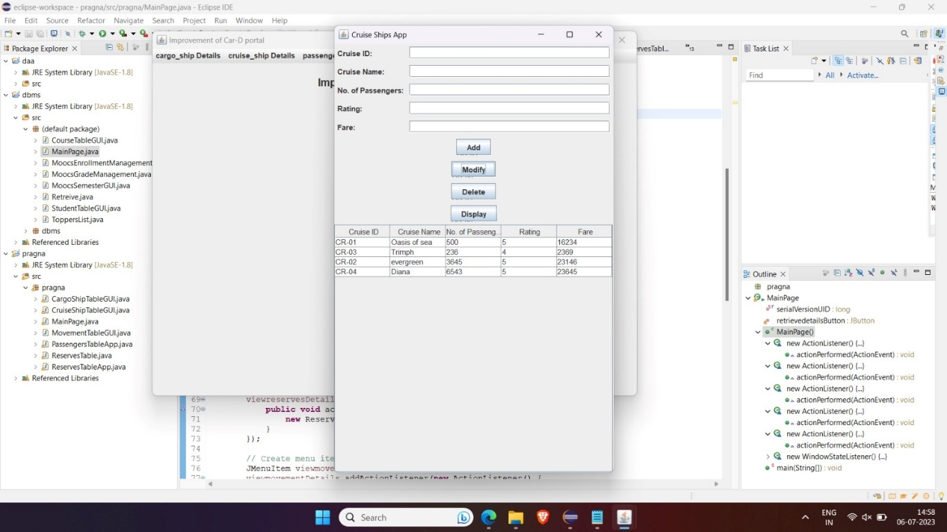

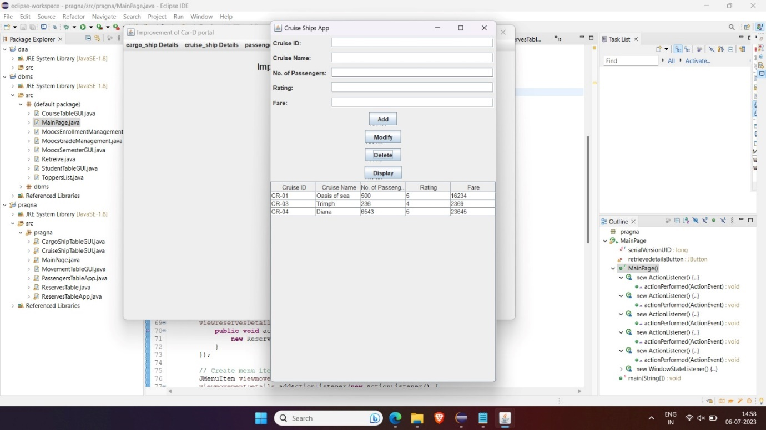

**3.CargoShipTableApp:**

**Source code**

//package ShipDetails.Cargo;

import javax.swing.*;

import javax.swing.table.DefaultTableModel;

import java.awt.*;

import java.awt.event.ActionEvent;

import java.awt.event.ActionListener;

import java.sql.*;

import java.util.Vector;

public class CargoShipTableApp extends JFrame {

private DefaultTableModel model;

private JTable table;

private JTextField txtCargoName, txtCargoId, txtCapacity, txtTypeOfLoad;

private Connection connection;

private Statement statement;

public CargoShipTableApp() {

setDefaultCloseOperation(JFrame.EXIT_ON_CLOSE);

setTitle("Cargo Ship Table");

setSize(600, 400);

setLocationRelativeTo(null);

// Create table model

model = new DefaultTableModel();

model.addColumn("Cargo Name");

model.addColumn("Cargo ID");

model.addColumn("Capacity");

model.addColumn("Type of Load");

// Create table

table = new JTable(model);

JScrollPane scrollPane = new JScrollPane(table);

add(scrollPane, BorderLayout.CENTER);

// Create panel for input fields

JPanel inputPanel = new JPanel(new GridLayout(4, 2));

// Create input fields

JLabel lblCargoName = new JLabel("Cargo Name");

txtCargoName = new JTextField();

JLabel lblCargoId = new JLabel("Cargo ID");

txtCargoId = new JTextField();

JLabel lblCapacity = new JLabel("Capacity");

txtCapacity = new JTextField();

JLabel lblTypeOfLoad = new JLabel("Type of Load");

txtTypeOfLoad = new JTextField();

// Add input fields to the panel

inputPanel.add(lblCargoName);

inputPanel.add(txtCargoName);

inputPanel.add(lblCargoId);

inputPanel.add(txtCargoId);

inputPanel.add(lblCapacity);

inputPanel.add(txtCapacity);

inputPanel.add(lblTypeOfLoad);

inputPanel.add(txtTypeOfLoad);

// Create panel for buttons

JPanel buttonPanel = new JPanel();

// Create buttons

JButton btnInsert = new JButton("Insert");

JButton btnModify = new JButton("Modify");

JButton btnDelete = new JButton("Delete");

JButton btnDisplay = new JButton("Display");

// Add buttons to the panel

buttonPanel.add(btnInsert);

buttonPanel.add(btnModify);

buttonPanel.add(btnDelete);

buttonPanel.add(btnDisplay);

// Add panels to the frame

add(inputPanel, BorderLayout.NORTH);

add(buttonPanel, BorderLayout.SOUTH);

// Connect to the database

connectToDatabase();

// Insert button action listener

btnInsert.addActionListener(new ActionListener() {

@Override

public void actionPerformed(ActionEvent e) {

insertData();

}

});

// Modify button action listener

btnModify.addActionListener(new ActionListener() {

@Override

public void actionPerformed(ActionEvent e) {

modifyData();

}

});

// Delete button action listener

btnDelete.addActionListener(new ActionListener() {

@Override

public void actionPerformed(ActionEvent e) {

deleteData();

}

});

// Display button action listener

btnDisplay.addActionListener(new ActionListener() {

@Override

public void actionPerformed(ActionEvent e) {

displayData();

}

});

}

// Method to connect to the MySQL database

private void connectToDatabase() {

try {

String url = "jdbc:mysql://localhost:3306/dbms";

String username = "root";

String password = "pragna";

connection = DriverManager.getConnection(url, username, password);

statement = connection.createStatement();

} catch (SQLException e) {

e.printStackTrace();

}

}

// Method to insert data into the table

private void insertData() {

String cargoName = txtCargoName.getText();

String cargoId = txtCargoId.getText();

String capacity = txtCapacity.getText();

String typeOfLoad = txtTypeOfLoad.getText();

if (!cargoName.isEmpty() && !cargoId.isEmpty() && !capacity.isEmpty() && !typeOfLoad.isEmpty()) {

try {

String query = "INSERT INTO cargo_ship (Cargo_name, Cargo_id, Capacity, Type_of_load) " +

"VALUES ('" + cargoName + "', '" + cargoId + "', " + capacity + ", '" + typeOfLoad + "')";

statement.executeUpdate(query);

Object[] row = {cargoName, cargoId, capacity, typeOfLoad};

model.addRow(row);

clearFields();

} catch (SQLException e) {

e.printStackTrace();

}

} else {

JOptionPane.showMessageDialog(this, "Please fill in all fields.", "Error", JOptionPane.ERROR_MESSAGE);

}

}

// Method to modify data in the table

private void modifyData() {

int selectedRow = table.getSelectedRow();

if (selectedRow != -1) {

String cargoName = txtCargoName.getText();

String cargoId = txtCargoId.getText();

String capacity = txtCapacity.getText();

String typeOfLoad = txtTypeOfLoad.getText();

if (!cargoName.isEmpty() && !cargoId.isEmpty() && !capacity.isEmpty() && !typeOfLoad.isEmpty()) {

try {

String query = "UPDATE cargo_ship SET Cargo_name = '" + cargoName + "', Cargo_id = '" + cargoId +

"', Capacity = " + capacity + ", Type_of_load = '" + typeOfLoad +

"' WHERE Cargo_id = '" + table.getValueAt(selectedRow, 1) + "'";

statement.executeUpdate(query);

table.setValueAt(cargoName, selectedRow, 0);

table.setValueAt(cargoId, selectedRow, 1);

table.setValueAt(capacity, selectedRow, 2);

table.setValueAt(typeOfLoad, selectedRow, 3);

clearFields();

} catch (SQLException e) {

e.printStackTrace();

}

} else {

JOptionPane.showMessageDialog(this, "Please fill in all fields.", "Error", JOptionPane.ERROR_MESSAGE);

}

} else {

JOptionPane.showMessageDialog(this, "Please select a row to modify.", "Error", JOptionPane.ERROR_MESSAGE);

}

}

// Method to delete data from the table

private void deleteData() {

int selectedRow = table.getSelectedRow();

if (selectedRow != -1) {

try {

String cargoId = (String) table.getValueAt(selectedRow, 1);

String query = "DELETE FROM cargo_ship WHERE Cargo_id = '" + cargoId + "'";

statement.executeUpdate(query);

model.removeRow(selectedRow);

clearFields();

} catch (SQLException e) {

e.printStackTrace();

}

} else {

JOptionPane.showMessageDialog(this, "Please select a row to delete.", "Error", JOptionPane.ERROR_MESSAGE);

}

}

// Method to display the selected data in the input fields

private void displayData() {

try{

String sql = "select * from cargo_ship";

Statement stmt = connection.createStatement();

ResultSet resultset = statement.executeQuery(sql);

while(resultset.next()){

String cargoName = resultset.getString("cargo_name");

String cargoId = resultset.getString("cargo_id");

String capacity = resultset.getString("capacity");

String type_of_load = resultset.getString("type_of_load");

Object[] row = { cargoName,cargoId,capacity,type_of_load};

model.addRow(row);

}

resultset.close();

}catch(SQLException e){

e.printStackTrace();

}

}

// Method to clear input fields

private void clearFields() {

txtCargoName.setText("");

txtCargoId.setText("");

txtCapacity.setText("");

txtTypeOfLoad.setText("");

}

/* public static void main(String[] args) {

SwingUtilities.invokeLater(new Runnable() {

@Override

public void run() {

new CargoShipTableApp().setVisible(true);

}

});

}*/

}

OUTPUT:

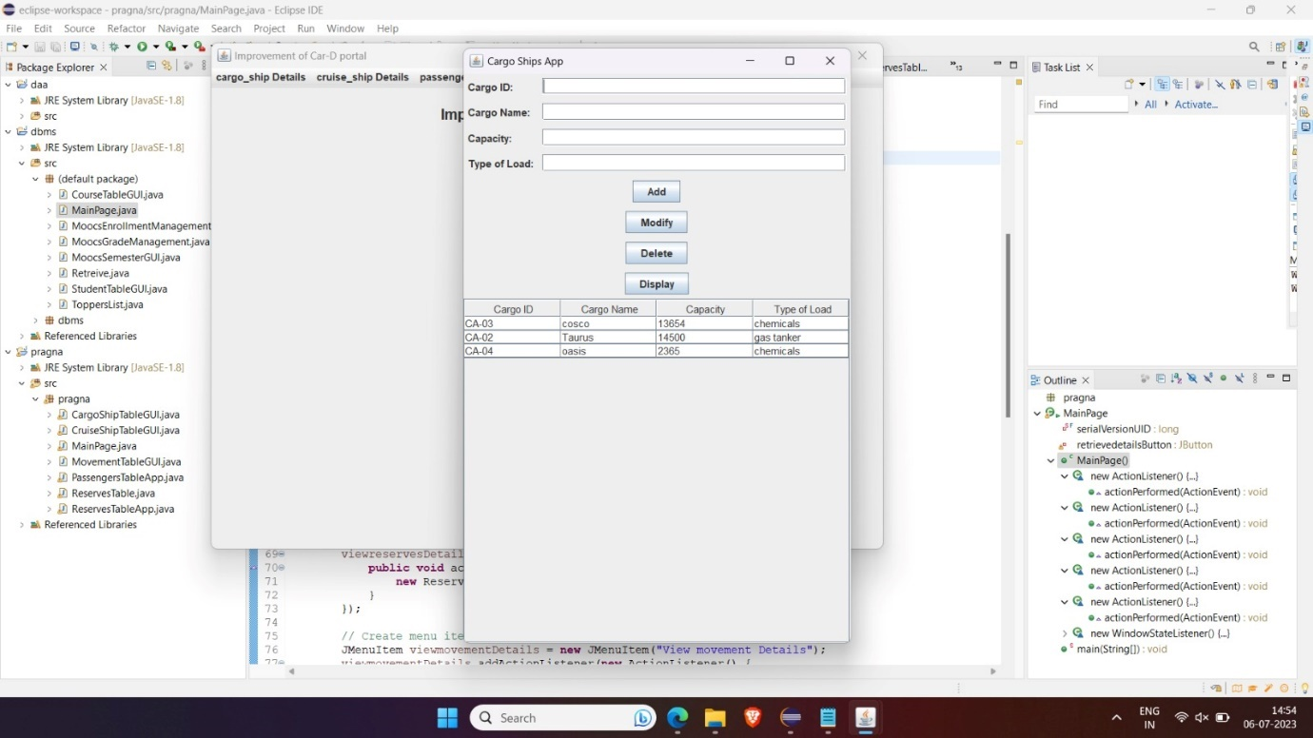

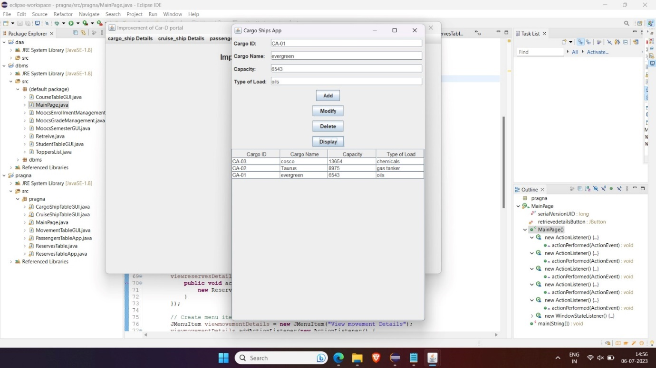

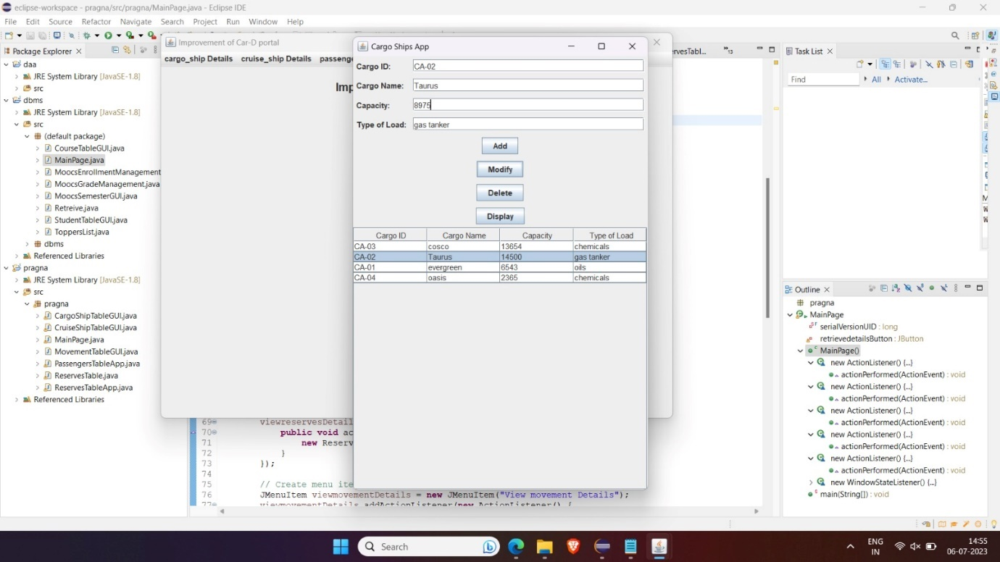

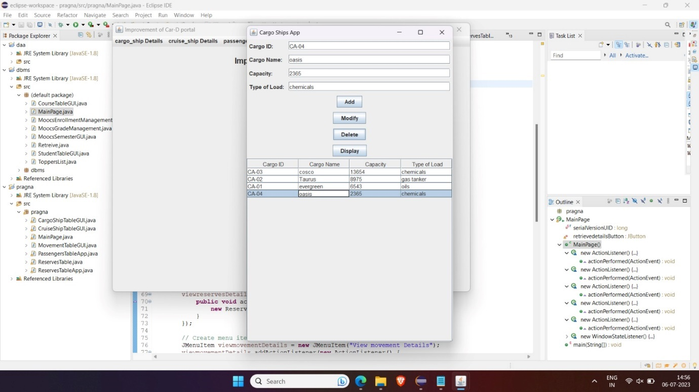

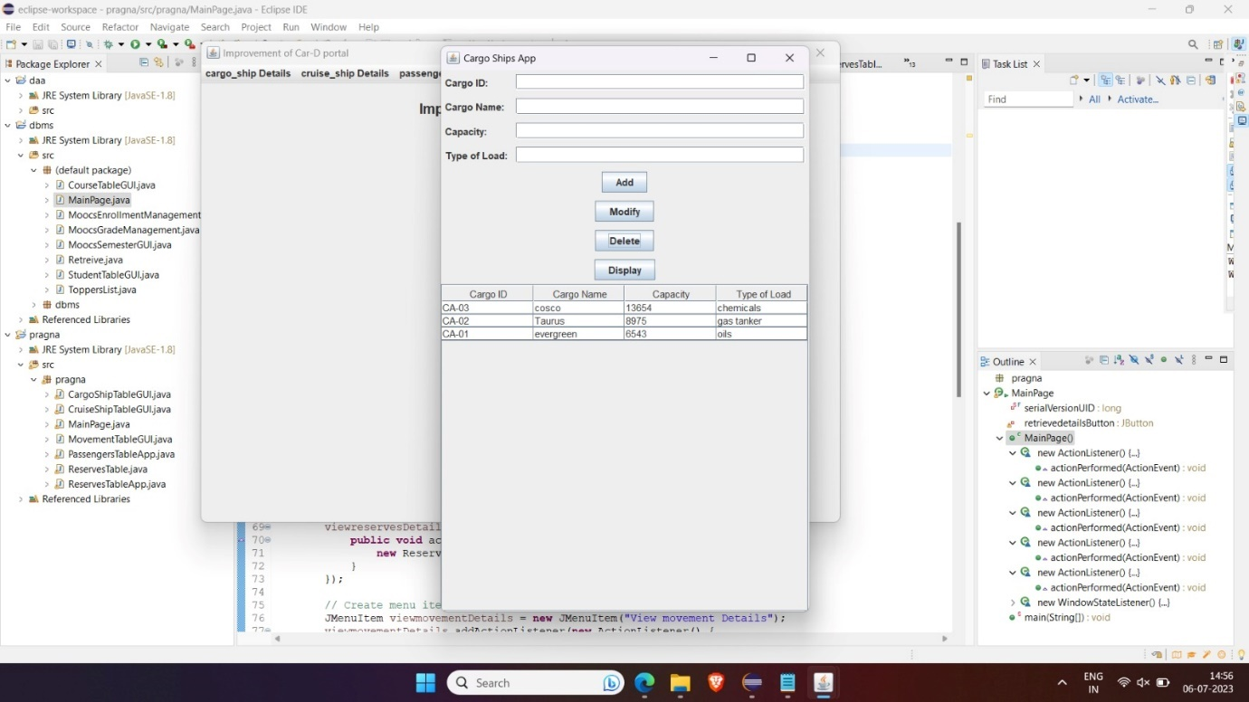

**4.Movement**

**Source code**

import javax.swing.*;

import javax.swing.table.DefaultTableModel;

import java.awt.*;

import java.awt.event.ActionEvent;

import java.awt.event.ActionListener;

import java.sql.*;

import java.util.Vector;

public class MovementTableApp extends JFrame {

private DefaultTableModel model;

private JTable table;

private JTextField txtStartingPort, txtDestinationPort, txtShipId, txtStartingDate;

private Connection connection;

private Statement statement;

public MovementTableApp() {

setDefaultCloseOperation(JFrame.EXIT_ON_CLOSE);

setTitle("Movement Table");

setSize(600, 400);

setLocationRelativeTo(null);

// Create table model

model = new DefaultTableModel();

model.addColumn("Starting Port");

model.addColumn("Destination Port");

model.addColumn("Ship ID");

model.addColumn("Starting Date");

// Create table

table = new JTable(model);

JScrollPane scrollPane = new JScrollPane(table);

add(scrollPane, BorderLayout.CENTER);

// Create panel for input fields

JPanel inputPanel = new JPanel(new GridLayout(4, 2));

// Create input fields

JLabel lblStartingPort = new JLabel("Starting Port");

txtStartingPort = new JTextField();

JLabel lblDestinationPort = new JLabel("Destination Port");

txtDestinationPort = new JTextField();

JLabel lblShipId = new JLabel("Ship ID");

txtShipId = new JTextField();

JLabel lblStartingDate = new JLabel("Starting Date");

txtStartingDate = new JTextField();

// Add input fields to the panel

inputPanel.add(lblStartingPort);

inputPanel.add(txtStartingPort);

inputPanel.add(lblDestinationPort);

inputPanel.add(txtDestinationPort);

inputPanel.add(lblShipId);

inputPanel.add(txtShipId);

inputPanel.add(lblStartingDate);

inputPanel.add(txtStartingDate);

// Create panel for buttons

JPanel buttonPanel = new JPanel();

// Create buttons

JButton btnInsert = new JButton("Insert");

JButton btnModify = new JButton("Modify");

JButton btnDelete = new JButton("Delete");

JButton btnDisplay = new JButton("Display");

// Add buttons to the panel

buttonPanel.add(btnInsert);

buttonPanel.add(btnModify);

buttonPanel.add(btnDelete);

buttonPanel.add(btnDisplay);

// Add panels to the frame

add(inputPanel, BorderLayout.NORTH);

add(buttonPanel, BorderLayout.SOUTH);

// Connect to the database

connectToDatabase();

// Insert button action listener

btnInsert.addActionListener(new ActionListener() {

@Override

public void actionPerformed(ActionEvent e) {

insertData();

}

});

// Modify button action listener

btnModify.addActionListener(new ActionListener() {

@Override

public void actionPerformed(ActionEvent e) {

modifyData();

}

});

// Delete button action listener

btnDelete.addActionListener(new ActionListener() {

@Override

public void actionPerformed(ActionEvent e) {

deleteData();

}

});

// Display button action listener

btnDisplay.addActionListener(new ActionListener() {

@Override

public void actionPerformed(ActionEvent e) {

displayData();

}

});

}

// Method to connect to the MySQL database

private void connectToDatabase() {

try {

String url = "jdbc:mysql://localhost:3306/dbms";

String username = "root";

String password = "pragna";

connection = DriverManager.getConnection(url, username, password);

statement = connection.createStatement();

} catch (SQLException e) {

e.printStackTrace();

}

}

// Method to insert data into the table

private void insertData() {

String startingPort = txtStartingPort.getText();

String destinationPort = txtDestinationPort.getText();

String shipId = txtShipId.getText();

String startingDate = txtStartingDate.getText();

if (!startingPort.isEmpty() && !destinationPort.isEmpty() && !shipId.isEmpty() && !startingDate.isEmpty()) {

try {

String query = "INSERT INTO movement (Starting_port, Destination_port, Ship_id, Starting_date) " +

"VALUES ('" + startingPort + "', '" + destinationPort + "', '" + shipId + "', '" + startingDate + "')";

statement.executeUpdate(query);

Vector<String> row = new Vector<>();

row.add(startingPort);

row.add(destinationPort);

row.add(shipId);

row.add(startingDate);

model.addRow(row);

clearFields();

} catch (SQLException e) {

e.printStackTrace();

}

} else {

JOptionPane.showMessageDialog(this, "Please fill in all fields.", "Error", JOptionPane.ERROR_MESSAGE);

}

}

// Method to modify data in the table

private void modifyData() {

int selectedRow = table.getSelectedRow();

if (selectedRow != -1) {

String startingPort = txtStartingPort.getText();

String destinationPort = txtDestinationPort.getText();

String shipId = txtShipId.getText();

String startingDate = txtStartingDate.getText();

if (!startingPort.isEmpty() && !destinationPort.isEmpty() && !shipId.isEmpty() && !startingDate.isEmpty()) {

try {

String query = "UPDATE movement SET Starting_port = '" + startingPort +

"', Destination_port = '" + destinationPort +

"', Ship_id = '" + shipId +

"', Starting_date = '" + startingDate +

"' WHERE Ship_id = '" + table.getValueAt(selectedRow, 2) + "'";

statement.executeUpdate(query);

table.setValueAt(startingPort, selectedRow, 0);

table.setValueAt(destinationPort, selectedRow, 1);

table.setValueAt(shipId, selectedRow, 2);

table.setValueAt(startingDate, selectedRow, 3);

clearFields();

} catch (SQLException e) {

e.printStackTrace();

}

} else {

JOptionPane.showMessageDialog(this, "Please fill in all fields.", "Error", JOptionPane.ERROR_MESSAGE);

}

} else {

JOptionPane.showMessageDialog(this, "Please select a row to modify.", "Error", JOptionPane.ERROR_MESSAGE);

}

}

// Method to delete data from the table

private void deleteData() {

int selectedRow = table.getSelectedRow();

if (selectedRow != -1) {

try {

String shipId = (String) table.getValueAt(selectedRow, 2);

String query = "DELETE FROM movement WHERE Ship_id = '" + shipId + "'";

statement.executeUpdate(query);

model.removeRow(selectedRow);

clearFields();

} catch (SQLException e) {

e.printStackTrace();

}

} else {

JOptionPane.showMessageDialog(this, "Please select a row to delete.", "Error", JOptionPane.ERROR_MESSAGE);

}

}

// Method to display the selected data in the input fields

private void displayData() {

int selectedRow = table.getSelectedRow();

if (selectedRow != -1) {

String startingPort = (String) table.getValueAt(selectedRow, 0);

String destinationPort = (String) table.getValueAt(selectedRow, 1);

String shipId = (String) table.getValueAt(selectedRow, 2);

String startingDate = (String) table.getValueAt(selectedRow, 3);

txtStartingPort.setText(startingPort);

txtDestinationPort.setText(destinationPort);

txtShipId.setText(shipId);

txtStartingDate.setText(startingDate);

} else {

JOptionPane.showMessageDialog(this, "Please select a row to display.", "Error", JOptionPane.ERROR_MESSAGE);

}

}

// Method to clear input fields

private void clearFields() {

txtStartingPort.setText("");

txtDestinationPort.setText("");

txtShipId.setText("");

txtStartingDate.setText("");

}

/* public static void main(String[] args) {

SwingUtilities.invokeLater(new Runnable() {

@Override

public void run() {

new MovementTableApp().setVisible(true);

}

});

}*/

}

OUTPUT:

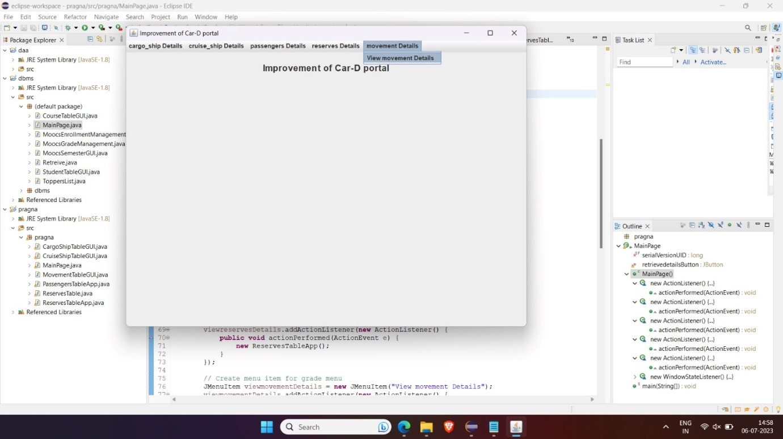

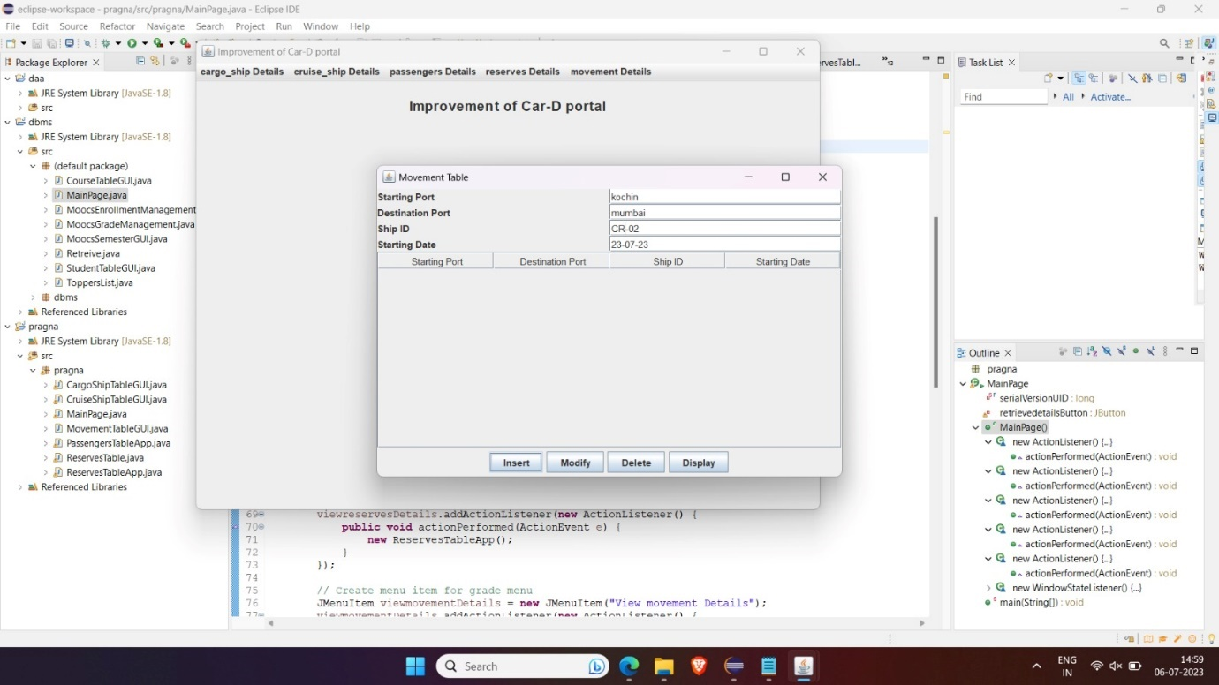

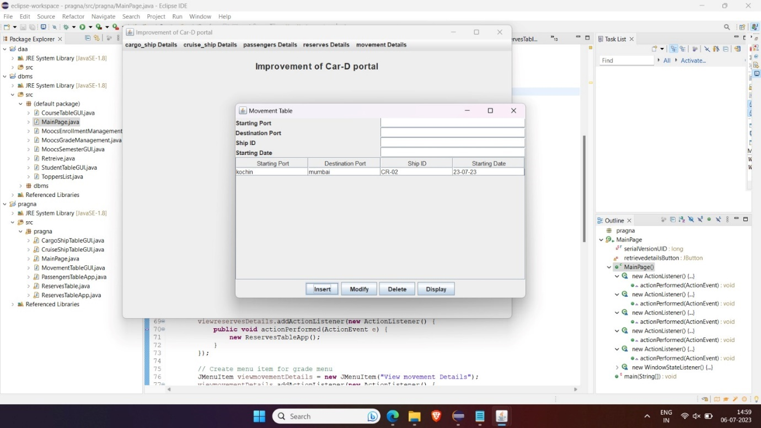

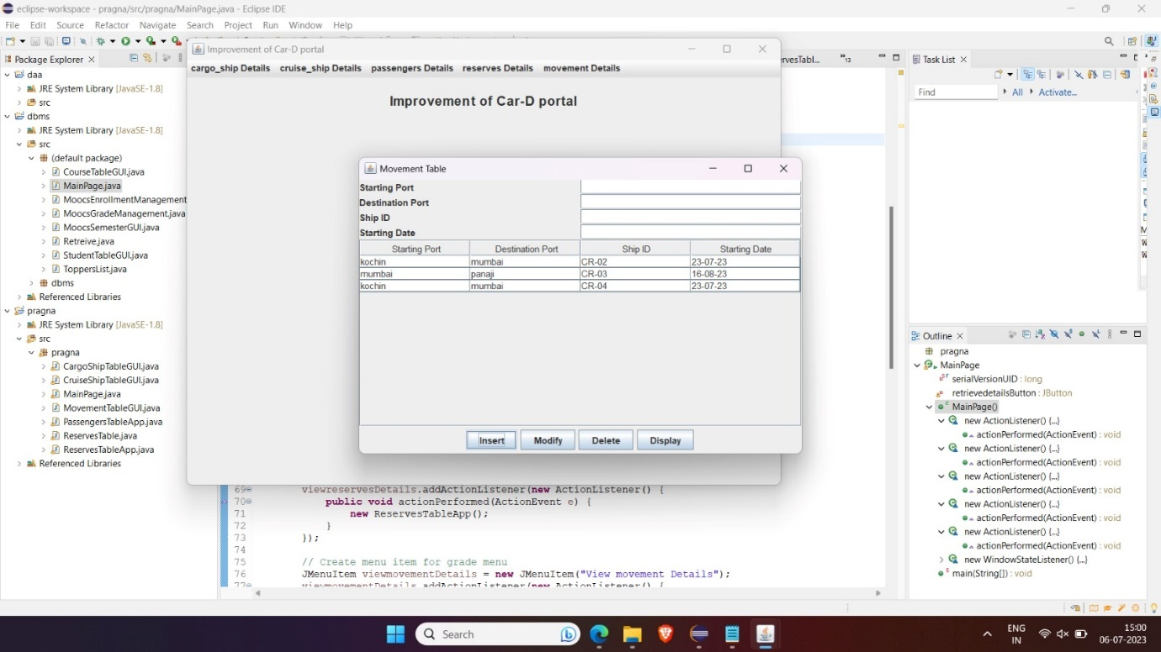

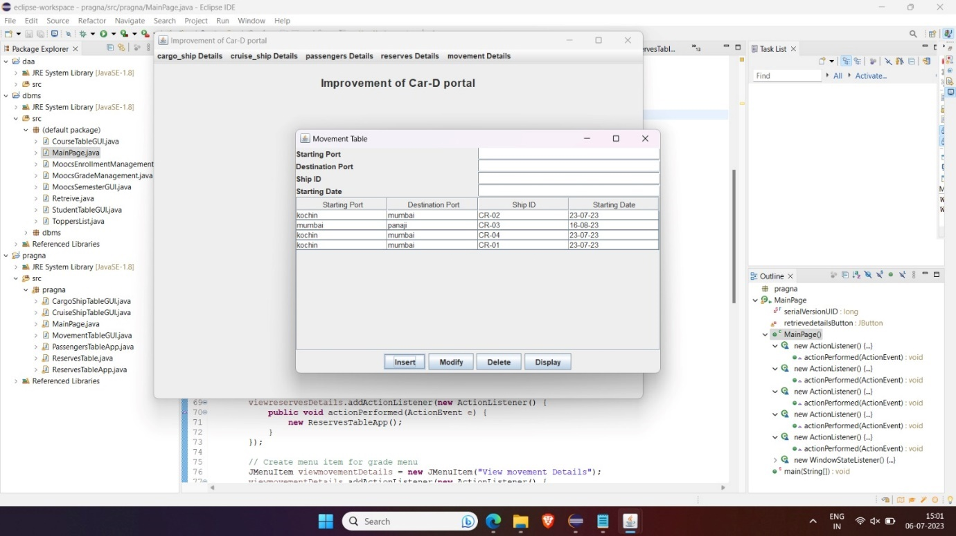

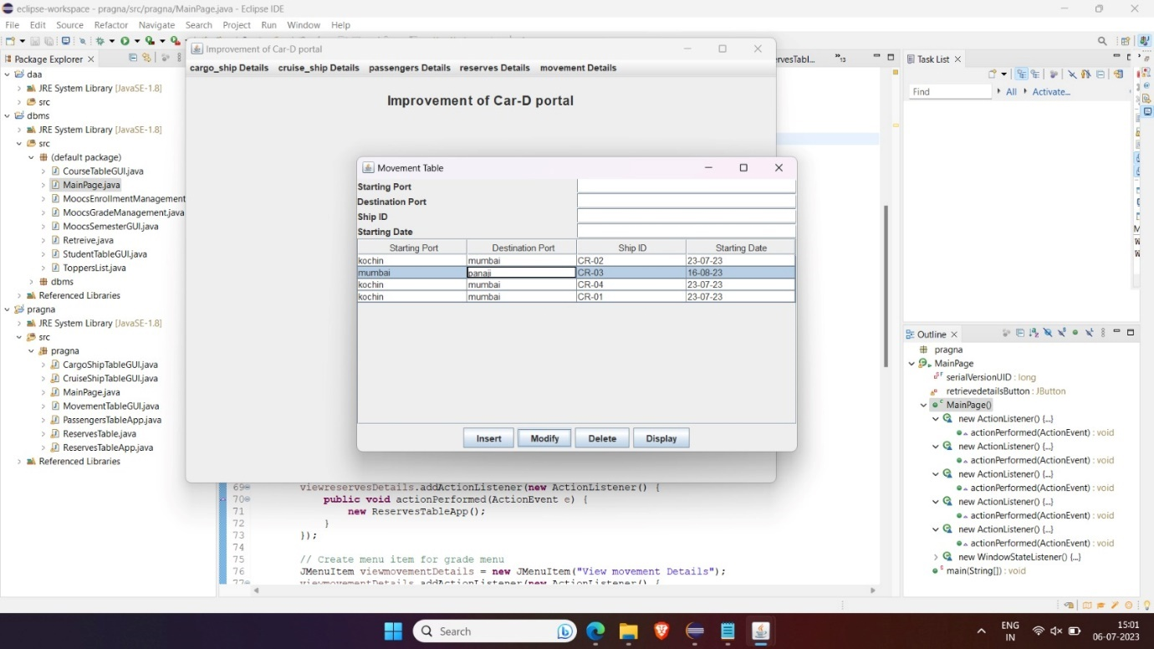

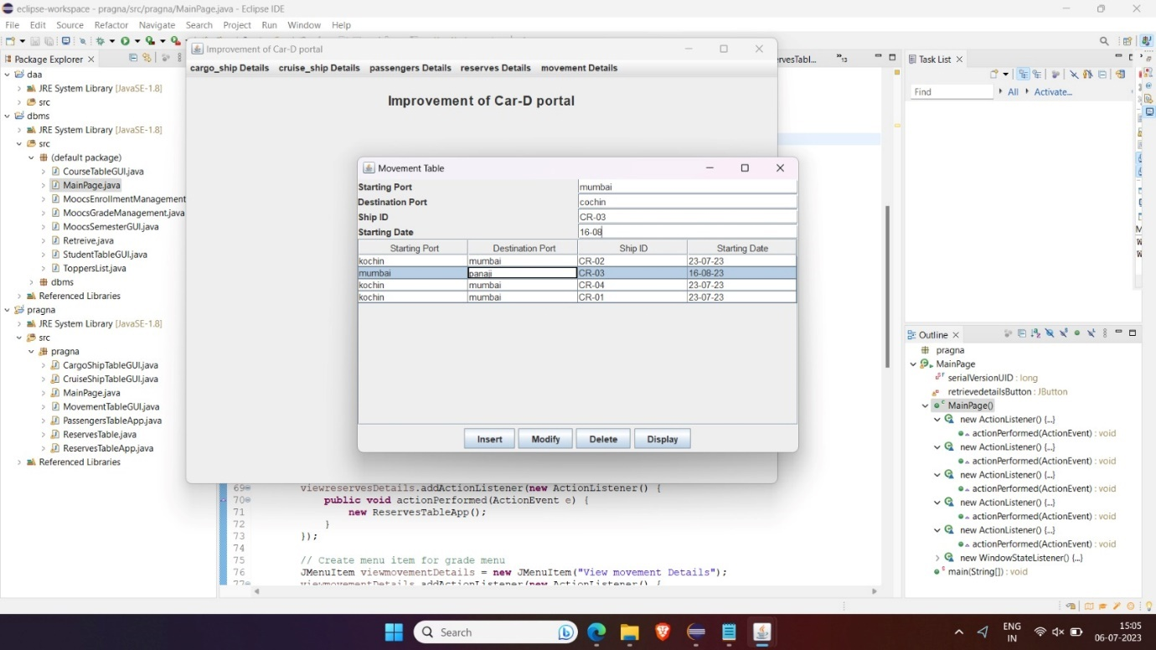

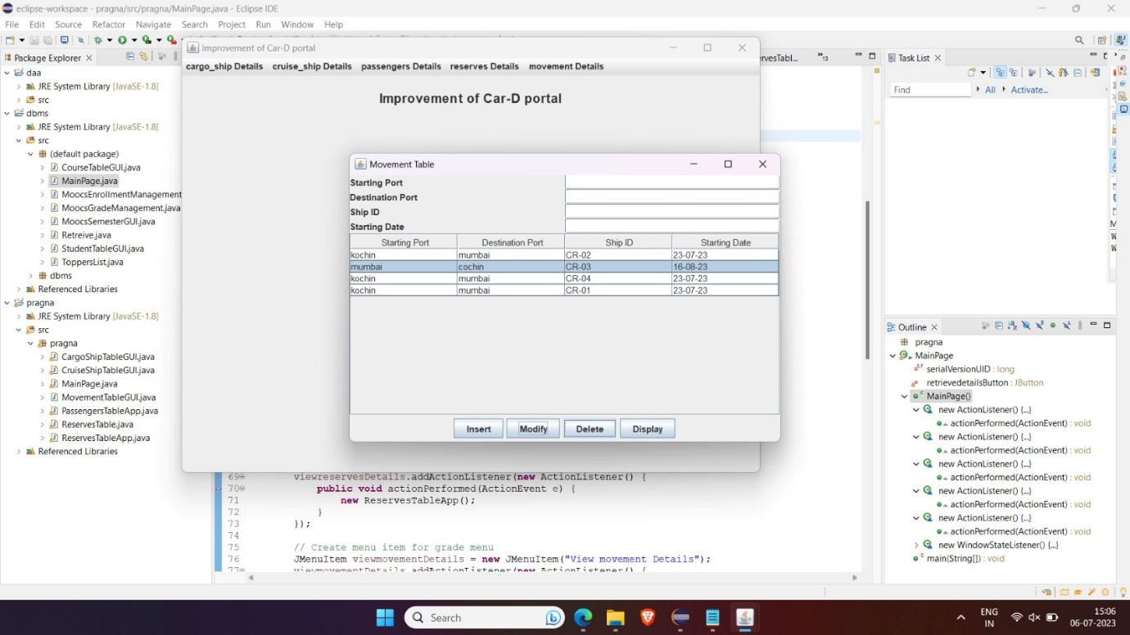

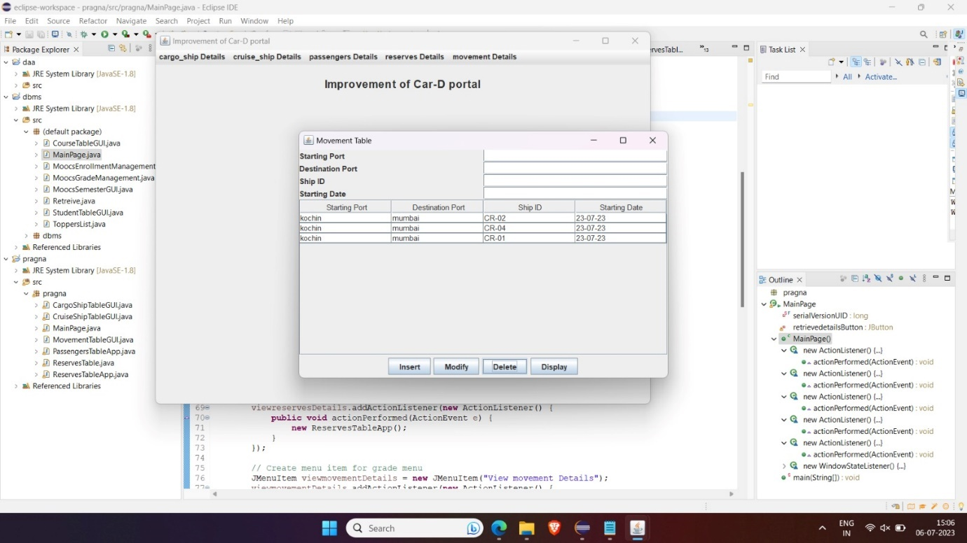

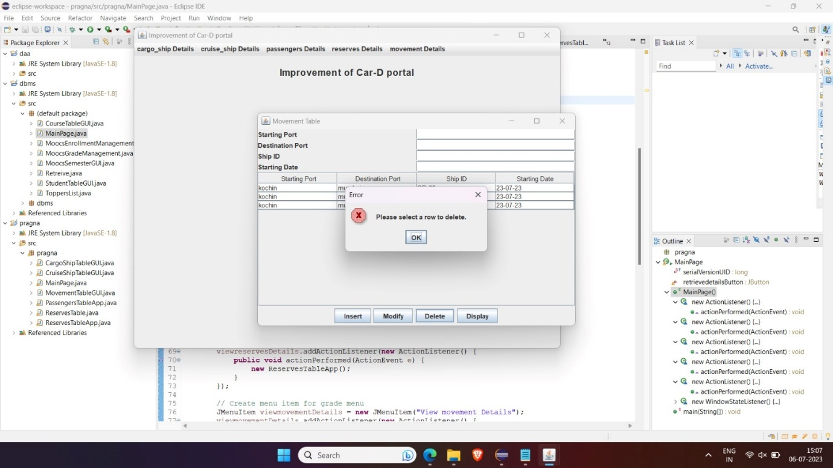

**5.Reserves:**

**Source code**

import javax.swing.*;

import java.awt.*;

import java.awt.event.ActionEvent;

import java.awt.event.ActionListener;

import java.sql.*;

import java.util.HashSet;

import java.util.Random;

import java.util.Set;

import java.util.Vector;

public class ReservesTableApp extends JFrame {

private JTextField txtDate, txtStartingPort, txtDestinationPort, txtName;

private JComboBox<String> cmbShips;

private JTextArea txtReservationDetails;

private Connection connection;

private Statement statement;

private Set<String> bookedIds;

public ReservesTableApp() {

setDefaultCloseOperation(JFrame.EXIT_ON_CLOSE);

setTitle("Reserves Table");

setSize(400, 400);

setLocationRelativeTo(null);

// Create panel for input fields

JPanel inputPanel = new JPanel(new GridLayout(6, 2));

// Create input fields

JLabel lblDate = new JLabel("Date");

txtDate = new JTextField();

JLabel lblStartingPort = new JLabel("Starting Port");

txtStartingPort = new JTextField();

JLabel lblDestinationPort = new JLabel("Destination Port");

txtDestinationPort = new JTextField();

JLabel lblName = new JLabel("Name");

txtName = new JTextField();

JLabel lblShip = new JLabel("Ship");

// Create combo box for ship selection

cmbShips = new JComboBox<>();

cmbShips.setEnabled(false);

// Add input fields to the panel

inputPanel.add(lblDate);

inputPanel.add(txtDate);

inputPanel.add(lblStartingPort);

inputPanel.add(txtStartingPort);

inputPanel.add(lblDestinationPort);

inputPanel.add(txtDestinationPort);

inputPanel.add(lblName);

inputPanel.add(txtName);

inputPanel.add(lblShip);

inputPanel.add(cmbShips);

// Create panel for buttons

JPanel buttonPanel = new JPanel();

// Create buttons

JButton btnSearch = new JButton("Search");

JButton btnReserve = new JButton("Reserve");

// Add buttons to the panel

buttonPanel.add(btnSearch);

buttonPanel.add(btnReserve);

// Create panel for reservation details

JPanel reservationPanel = new JPanel(new BorderLayout());

JLabel lblReservationDetails = new JLabel("Reservation Details:");

txtReservationDetails = new JTextArea();

txtReservationDetails.setEditable(false);

JScrollPane scrollPane = new JScrollPane(txtReservationDetails);

// Add components to the reservation panel

reservationPanel.add(lblReservationDetails, BorderLayout.NORTH);

reservationPanel.add(scrollPane, BorderLayout.CENTER);

// Add panels to the frame

add(inputPanel, BorderLayout.NORTH);

add(buttonPanel, BorderLayout.CENTER);

add(reservationPanel, BorderLayout.SOUTH);

// Connect to the database

connectToDatabase();

// Search button action listener

btnSearch.addActionListener(new ActionListener() {

@Override

public void actionPerformed(ActionEvent e) {

searchShips();

}

});

// Reserve button action listener

btnReserve.addActionListener(new ActionListener() {

@Override

public void actionPerformed(ActionEvent e) {

reserveShip();

}

});

// Initialize the set of booked IDs

bookedIds = new HashSet<>();

}

// Method to connect to the MySQL database

private void connectToDatabase() {

try {

String url = "jdbc:mysql://localhost:3306/dbms";

String username = "root";

String password = "pragna";

connection = DriverManager.getConnection(url, username, password);

statement = connection.createStatement();

} catch (SQLException e) {

e.printStackTrace();

}

}

// Method to search for available ships on a given date and route

private void searchShips() {

String date = txtDate.getText();

String startingPort = txtStartingPort.getText();

String destinationPort = txtDestinationPort.getText();

if (!date.isEmpty() && !startingPort.isEmpty() && !destinationPort.isEmpty()) {

try {

String query = "SELECT ship_id FROM movement WHERE starting_port = '" + startingPort +

"' AND destination_port = '" + destinationPort + "' AND starting_date = '" + date + "'";

ResultSet resultSet = statement.executeQuery(query);

cmbShips.removeAllItems();

cmbShips.setEnabled(true);

while (resultSet.next()) {

String shipId = resultSet.getString("ship_id");

cmbShips.addItem(shipId);

}

if (cmbShips.getItemCount() == 0) {

JOptionPane.showMessageDialog(this, "No ships available.", "No Ships", JOptionPane.INFORMATION_MESSAGE);

}

} catch (SQLException e) {

e.printStackTrace();

}

} else {

JOptionPane.showMessageDialog(this, "Please fill in all fields.", "Error", JOptionPane.ERROR_MESSAGE);

}

}

// Method to reserve a ship and update the passengers table

private void reserveShip() {

String shipId = (String) cmbShips.getSelectedItem();

String bookingId = generateBookingId();

String name = txtName.getText();

if (!name.isEmpty()) {

try {

// Check if the ship is available on the specified date, starting port, and destination port

String query = "SELECT ship_id FROM movement WHERE starting_port = '" + txtStartingPort.getText() +

"' AND destination_port = '" + txtDestinationPort.getText() + "' AND starting_date = '" +

txtDate.getText() + "' AND ship_id = '" + shipId + "'";

ResultSet resultSet = statement.executeQuery(query);

if (!resultSet.next()) {

JOptionPane.showMessageDialog(this, "Cannot reserve as no ships are available.", "No Ships Available", JOptionPane.ERROR_MESSAGE);

return;

}

// Check if booking ID already exists

query = "SELECT booking_id FROM passengers WHERE booking_id = '" + bookingId + "'";

resultSet = statement.executeQuery(query);

if (resultSet.next()) {

// Booking ID already exists, generate a new one

bookingId = generateBookingId();

}

// Update reserves table

query = "INSERT INTO reserves (ship_id, booking_id, date_of_reservation, starting_port, destination_port) " +

"VALUES ('" + shipId + "', '" + bookingId + "', '" + txtDate.getText() + "', '" +

txtStartingPort.getText() + "', '" + txtDestinationPort.getText() + "')";

statement.executeUpdate(query);

// Update passengers table

query = "INSERT INTO passengers (booking_id, name) VALUES ('" + bookingId + "', '" + name + "')";

statement.executeUpdate(query);

// Display reservation details to the user

txtReservationDetails.setText("Reservation Details:\n\n" +

"Booking ID: " + bookingId + "\n" +

"Date of Reservation: " + txtDate.getText() + "\n" +

"Ship ID: " + shipId + "\n" +

"Starting Port: " + txtStartingPort.getText() + "\n" +

"Destination Port: " + txtDestinationPort.getText());

JOptionPane.showMessageDialog(this, "Reservation successful.\n\nBooking ID: " + bookingId, "Reservation Success", JOptionPane.INFORMATION_MESSAGE);

} catch (SQLException e) {

e.printStackTrace();

}

} else {

JOptionPane.showMessageDialog(this, "Please enter a name.", "Error", JOptionPane.ERROR_MESSAGE);

}

}

// Method to generate a booking ID of length 5

private String generateBookingId() {

Random random = new Random();

String bookingId;

do {

StringBuilder sb = new StringBuilder();

for (int i = 0; i < 5; i++) {

int digit = random.nextInt(10);

sb.append(digit);

}

bookingId = sb.toString();

} while (bookedIds.contains(bookingId));

bookedIds.add(bookingId);

return bookingId;

}

public static void main(String[] args) {

SwingUtilities.invokeLater(new Runnable() {

@Override

public void run() {

new ReservesTableApp().setVisible(true);

}

});

}

}

OUTPUT: 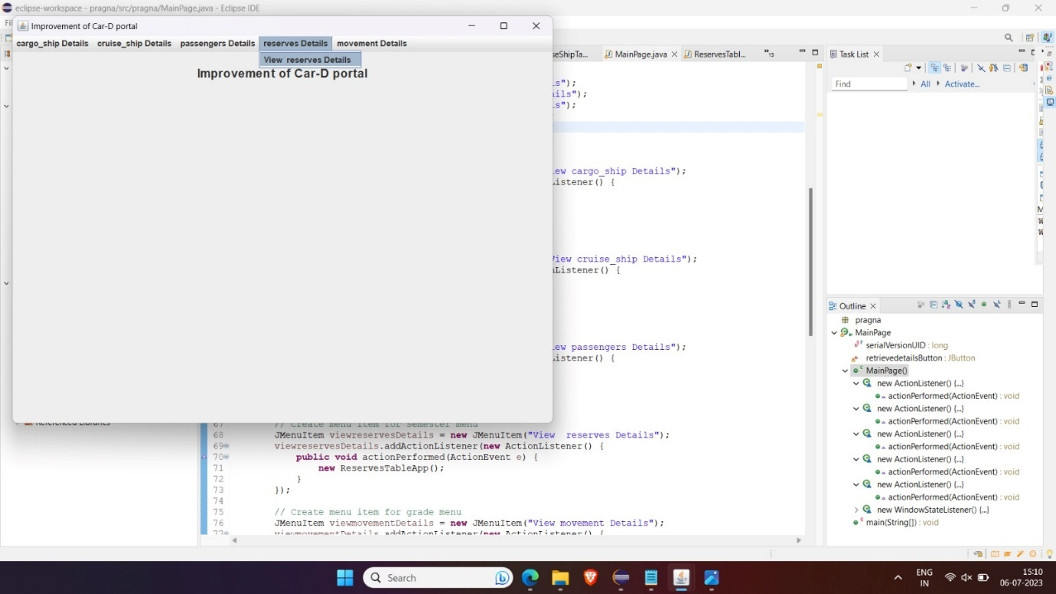

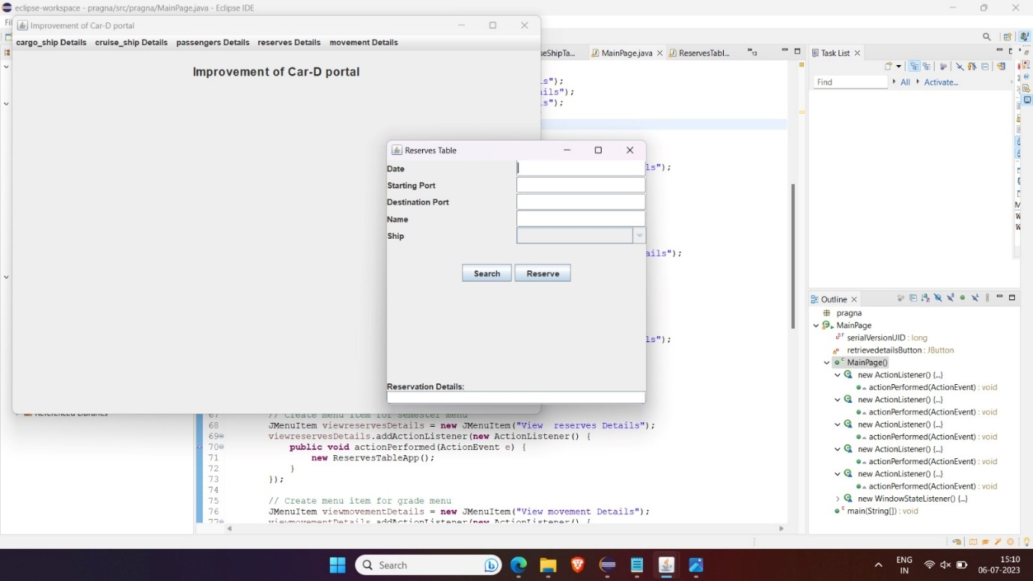

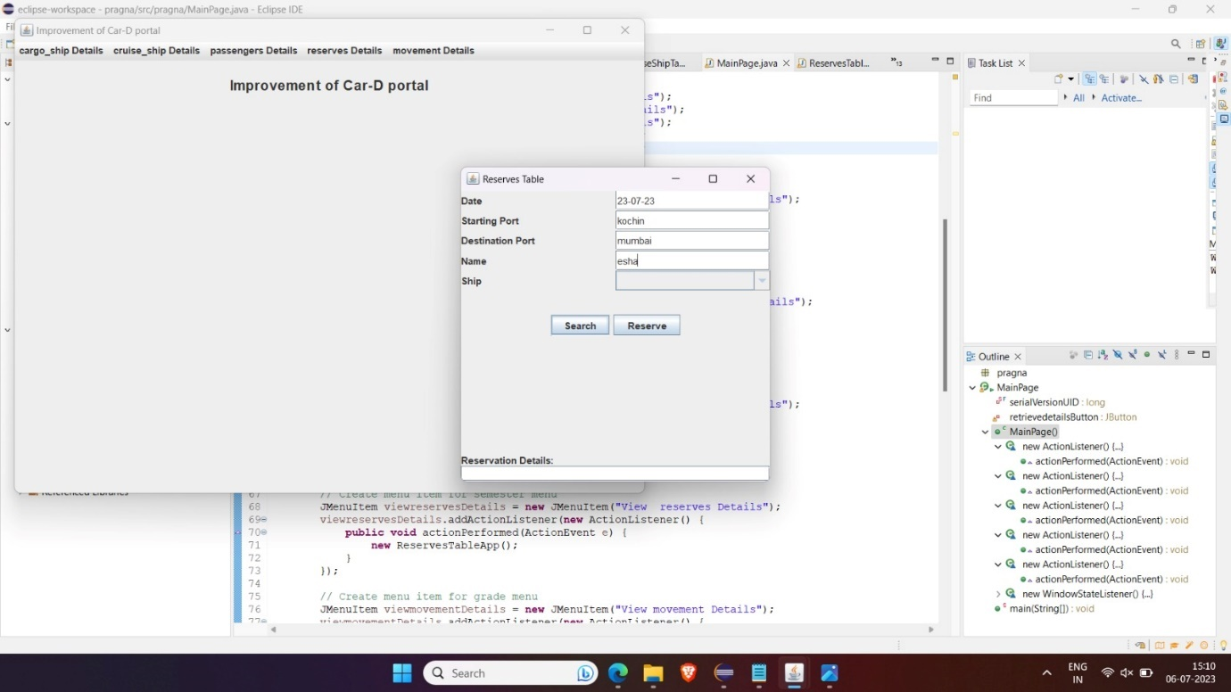

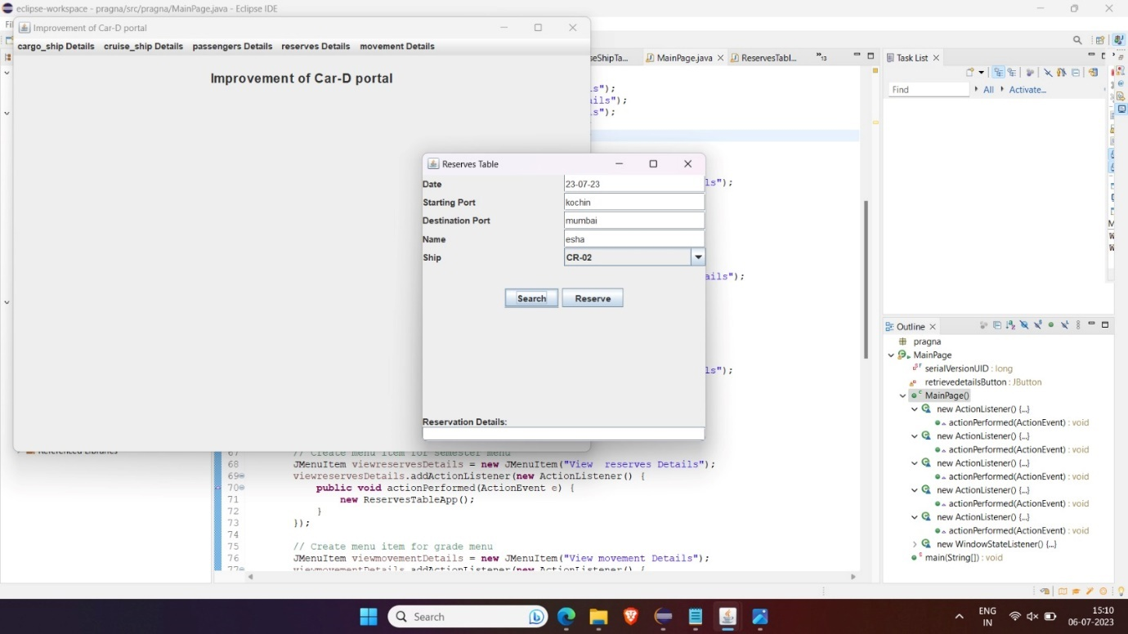

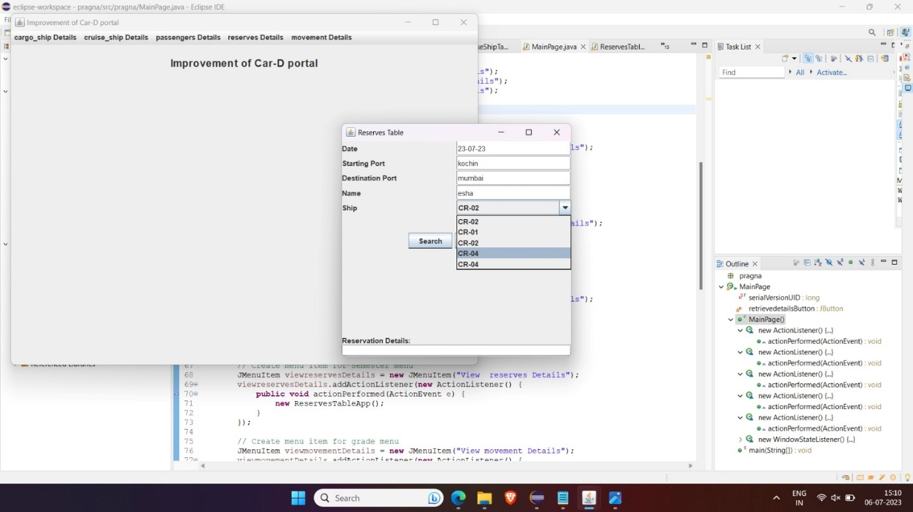

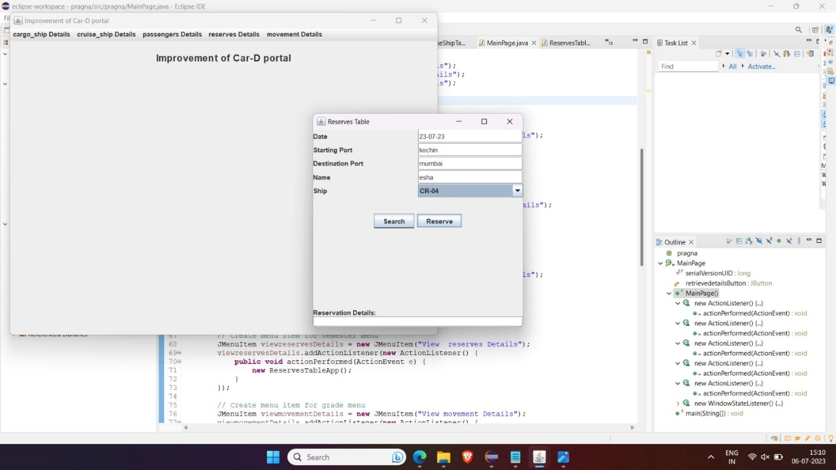

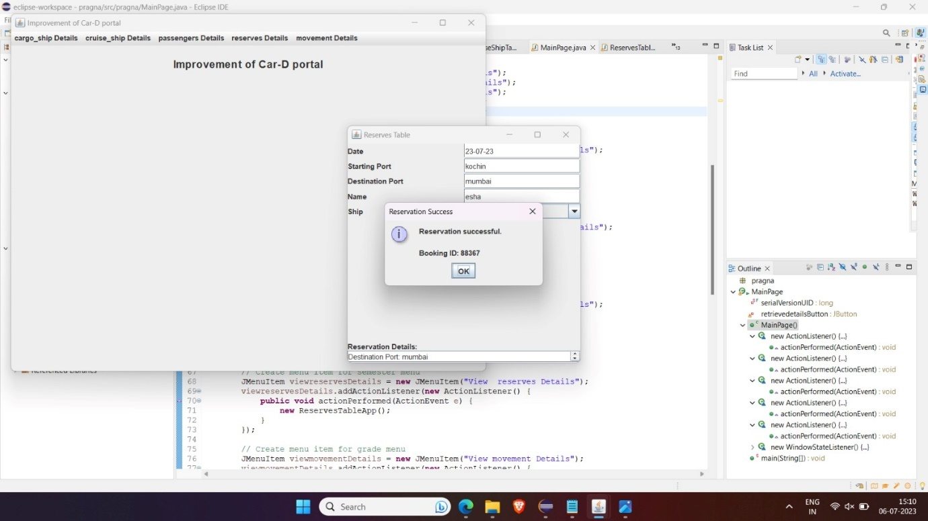

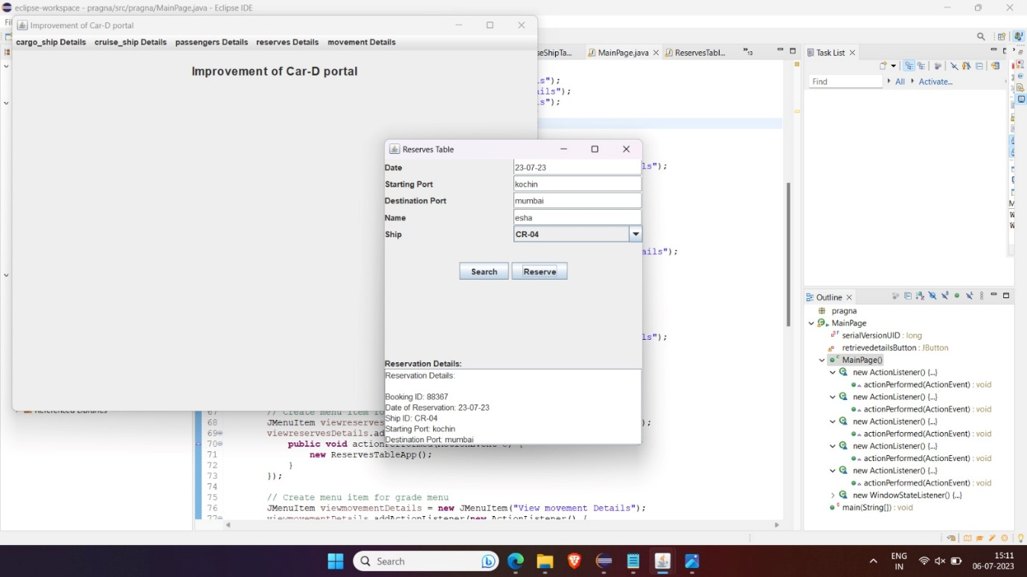

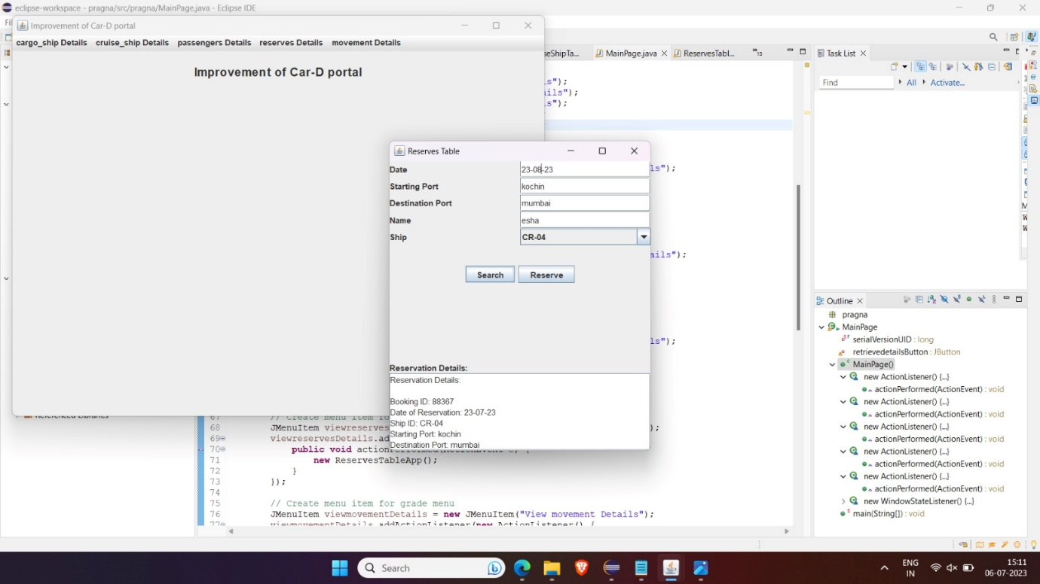

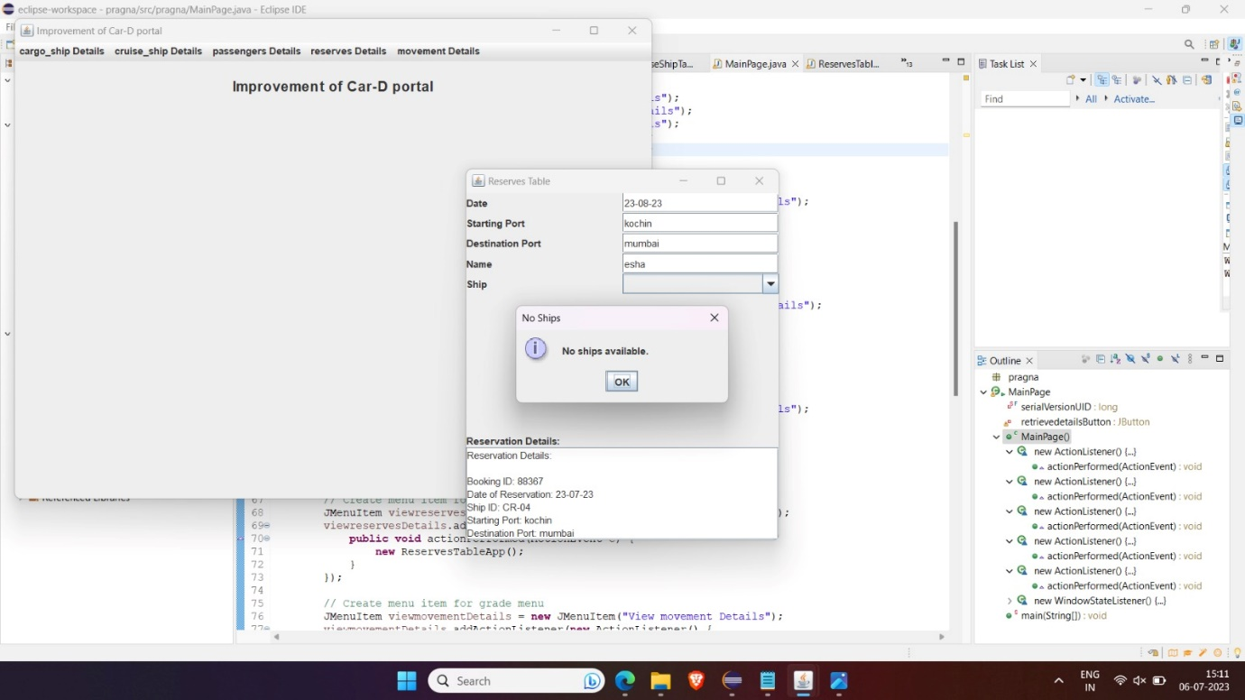

**6.Passengers :**

**Source code**

import javax.swing.*;

import javax.swing.table.DefaultTableModel;

import java.awt.*;

import java.awt.event.ActionEvent;

import java.awt.event.ActionListener;

import java.sql.*;

import java.util.Vector;

public class PassengersTableApp extends JFrame {

private DefaultTableModel model;

private JTable table;

private JTextField txtBookingId, txtName;

private Connection connection;

private Statement statement;

public PassengersTableApp() {

setDefaultCloseOperation(JFrame.EXIT_ON_CLOSE);

setTitle("Passengers Table");

setSize(600, 400);

setLocationRelativeTo(null);

// Create table model

model = new DefaultTableModel();

model.addColumn("Booking ID");

model.addColumn("Name");

// Create table

table = new JTable(model);

JScrollPane scrollPane = new JScrollPane(table);

add(scrollPane, BorderLayout.CENTER);

// Create panel for input fields

JPanel inputPanel = new JPanel(new GridLayout(2, 2));

// Create input fields

JLabel lblBookingId = new JLabel("Booking ID");

txtBookingId = new JTextField();

JLabel lblName = new JLabel("Name");

txtName = new JTextField();

// Add input fields to the panel

inputPanel.add(lblBookingId);

inputPanel.add(txtBookingId);

inputPanel.add(lblName);

inputPanel.add(txtName);

// Create panel for buttons

JPanel buttonPanel = new JPanel();

// Create buttons

JButton btnInsert = new JButton("Insert");

JButton btnDisplay = new JButton("Display");

JButton btnDelete = new JButton("Delete");

// Add buttons to the panel

buttonPanel.add(btnInsert);

buttonPanel.add(btnDisplay);

buttonPanel.add(btnDelete);

// Add panels to the frame

add(inputPanel, BorderLayout.NORTH);

add(buttonPanel, BorderLayout.SOUTH);

// Connect to the database

connectToDatabase();

// Insert button action listener

btnInsert.addActionListener(new ActionListener() {

@Override

public void actionPerformed(ActionEvent e) {

insertData();

}

});

// Display button action listener

btnDisplay.addActionListener(new ActionListener() {

@Override

public void actionPerformed(ActionEvent e) {

displayData();

}

});

// Delete button action listener

btnDelete.addActionListener(new ActionListener() {

@Override

public void actionPerformed(ActionEvent e) {

deleteData();

}

});

}

// Method to connect to the MySQL database

private void connectToDatabase() {

try {

String url = "jdbc:mysql://localhost:3306/dbms";

String username = "root";

String password = "pragna";

connection = DriverManager.getConnection(url, username, password);

statement = connection.createStatement();

} catch (SQLException e) {

e.printStackTrace();

}

}

// Method to insert data into the table

private void insertData() {

String bookingId = txtBookingId.getText();

String name = txtName.getText();

if (!bookingId.isEmpty() && !name.isEmpty()) {

try {

String query = "UPDATE passengers (Booking_id, Name) VALUES ('" + bookingId + "', '" + name + "')";

statement.executeUpdate(query);

Vector<String> row = new Vector<>();

row.add(bookingId);

row.add(name);

model.addRow(row);

clearFields();

} catch (SQLException e) {

e.printStackTrace();

}

} else {

JOptionPane.showMessageDialog(this, "Please fill in all fields.", "Error", JOptionPane.ERROR_MESSAGE);

}

}

// Method to display data from the table

private void displayData() {

try {

String query = "SELECT * FROM passengers";

ResultSet resultSet = statement.executeQuery(query);

model.setRowCount(0);

while (resultSet.next()) {

String bookingId = resultSet.getString("Booking_id");

String name = resultSet.getString("Name");

Vector<String> row = new Vector<>();

row.add(bookingId);

row.add(name);

model.addRow(row);

}

} catch (SQLException e) {

e.printStackTrace();

}

}

// Method to delete data from the table

private void deleteData() {

int selectedRow = table.getSelectedRow();

if (selectedRow != -1) {

try {

String bookingId = (String) table.getValueAt(selectedRow, 0);

String query = "DELETE FROM passengers WHERE Booking_id = '" + bookingId + "'";

statement.executeUpdate(query);

model.removeRow(selectedRow);

clearFields();

} catch (SQLException e) {

e.printStackTrace();

}

} else {

JOptionPane.showMessageDialog(this, "Please select a row to delete.", "Error", JOptionPane.ERROR_MESSAGE);

}

}

// Method to clear input fields

private void clearFields() {

txtBookingId.setText("");

txtName.setText("");

}

public static void main(String[] args) {

SwingUtilities.invokeLater(new Runnable() {

@Override

public void run() {

new PassengersTableApp().setVisible(true);

}

});

}

}

OUTPUT:

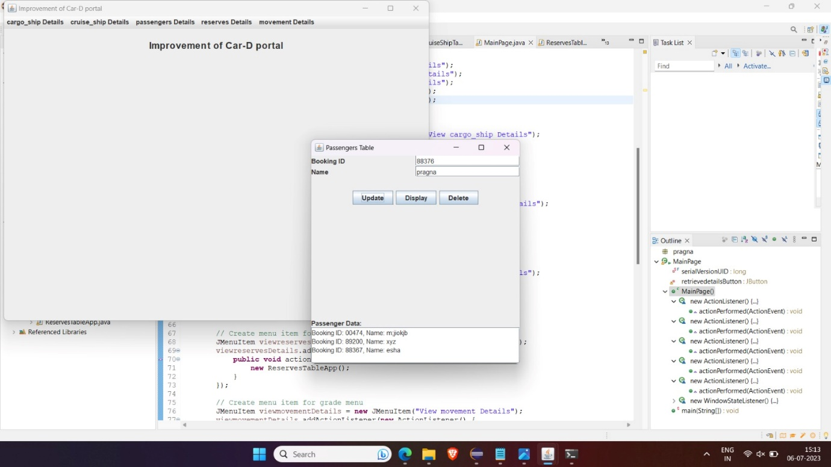

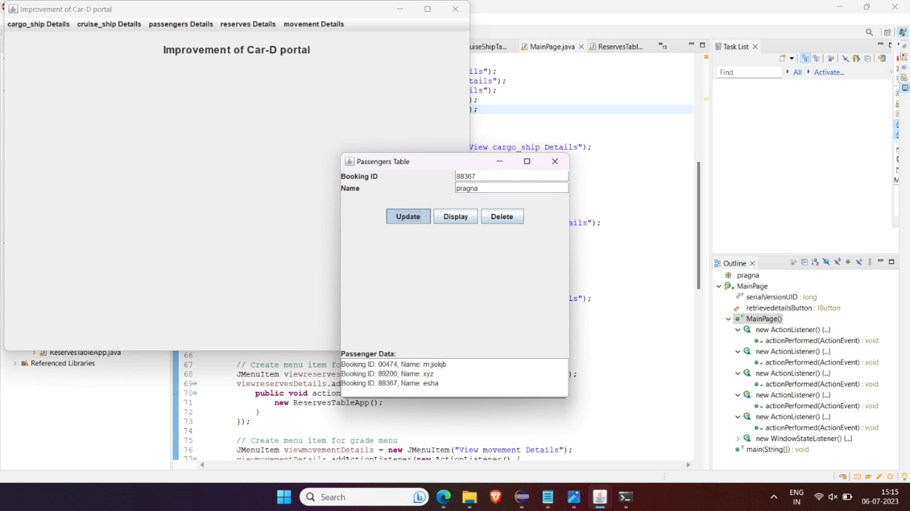

**RESULT**

I have successfully completed my DBMS project ‘**Car-D Portal*’***

**DISCUSSION AND FUTURE WORK**

This project is an application which helps the students access their highest-grade points from all the courses they have been certified for. It has a very basic user interface. Future scope would be to make the UI more appealing by using graphics. One more feature would be to allow student-users to upload their resumes and official documents required so that the project managers can take a look while they hire them during internship process or placements. We can also think of including a feedback system to allow the users to leave their valuable feedback after using this app. Making this feedback to be publicly viewable, would attract many more users to use this app.

**REFERENCES**

● https://docs.oracle.com/javase/7/docs/api/

● <https://www.javatpoint.com/java-swing>

● https://stackoverflow.com/